## Exercise: Creating workbooks

**How to complete this exercise**

To complete this exercise, you will need access to Microsoft 365 Excel.

**Note:** Keep in mind that if you are using free Office for the web or another version of the Microsoft 365 Excel application some features covered in this exercise may not be available.​

**Free Office for the web**

If you do not have access to Microsoft 365 Excel, you can use Free Office for the web. This version of Office allows you to view and edit files in apps like Word, Excel, and PowerPoint. This free service is available to anyone with a Microsoft account.

**Access Microsoft Account**

[Log in to your Microsoft account.](https://account.microsoft.com/) Type the email, phone number, or Skype sign-in that you use for other services (Outlook, Office, etc.), then select Next. If you don't have a Microsoft account, you can select No account? Create one!

**Let's get started!**

To use Microsoft 365, you will be given a username and password to access your online account. Once you have this information, open your browser (Edge, Firefox, Chrome, etc.) and then open the login page at [https://login.microsoftonline.com](https://login.microsoftonline.com/):

With the login page open, enter the e-mail address that was given to you, then click the **Next**button.

1. Type “Excel” into the search box on the Windows 10 taskbar:

Windows 10 taskbar open, typed "Excel" inside the Search box

2. Click the entry for Excel to start the program:

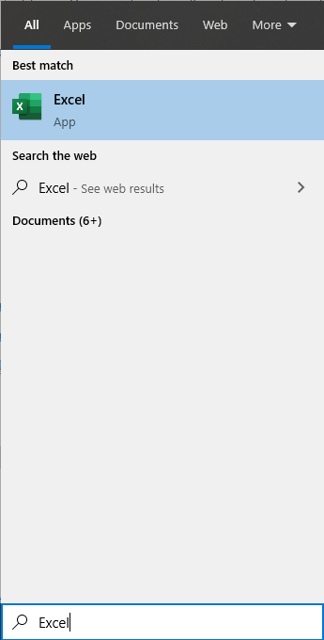

3. Microsoft Excel will start and prompt you to create a workbook using the Start screen. Click the thumbnail labelled “**Blank workbook**”:

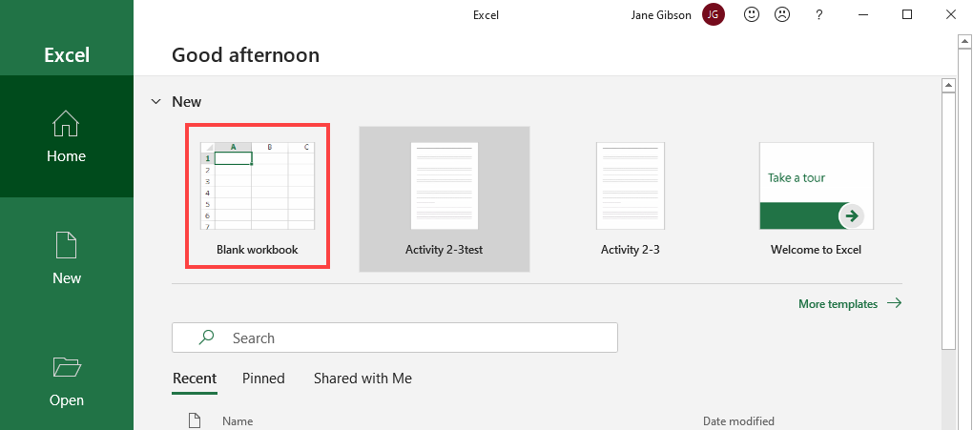

4. The new blank workbook will open and contain one empty worksheet:

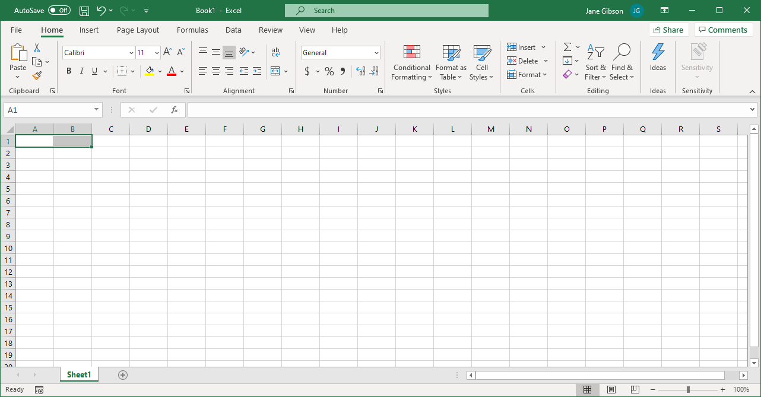

5. Click the **File** tab:

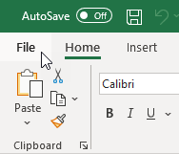

6. The Backstage view is now displayed. As you can see, there are several tabs and commands to choose from. For this example, click **Save**:

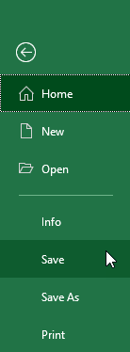

7. As you are saving this workbook for the first time, the Save As category of Backstage view will be displayed. Click **This PC**:

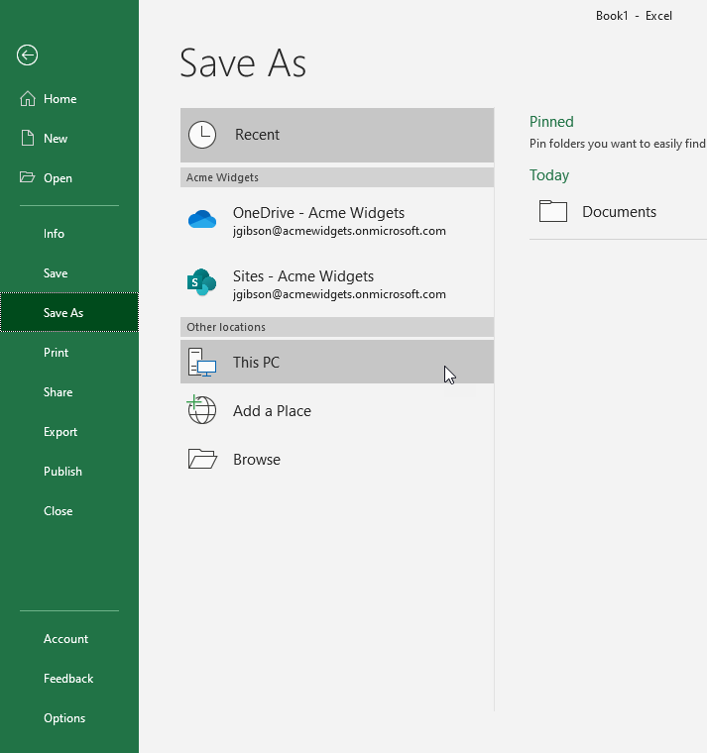

8. In the field labelled **Enter file name here**, type “**Activity 1-2 Complete**”:

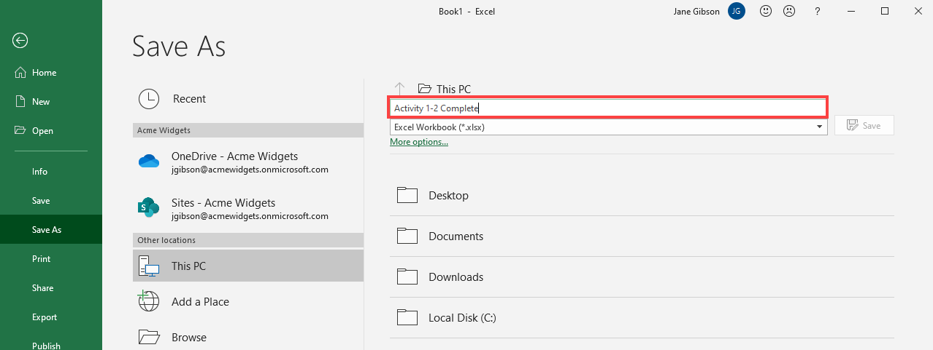

9. Now click to select the **Desktop** folder:

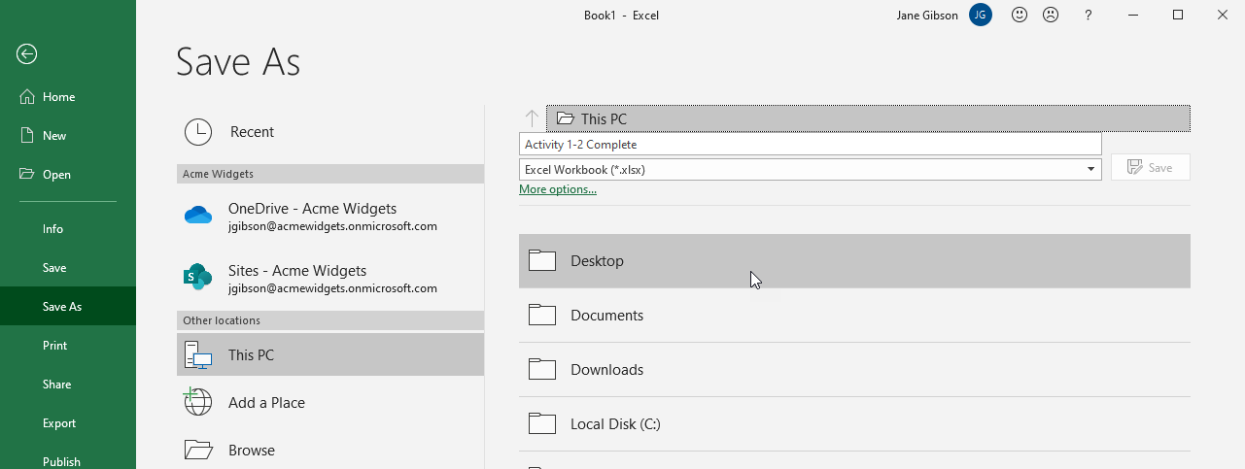

10. Below the file name field, click on the drop-down arrow to the right of the file type description to display the file types that can be used to save the current workbook:

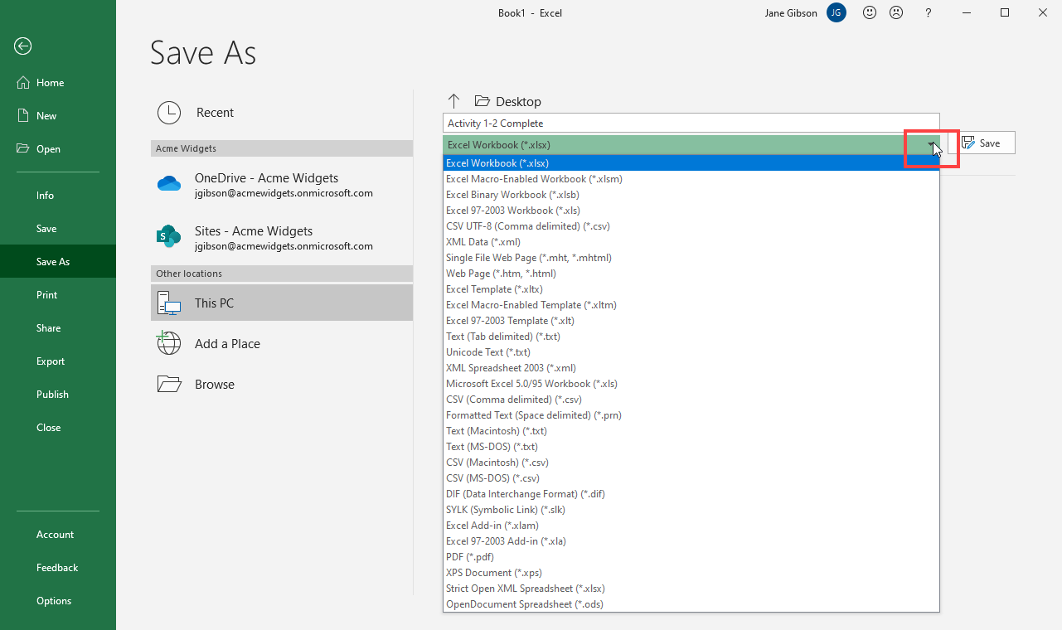

For this example, leave the default Excel Workbook type selected. (Click in a blank area of the Backstage view to close the menu without changing anything.)

11. Click **Save**:

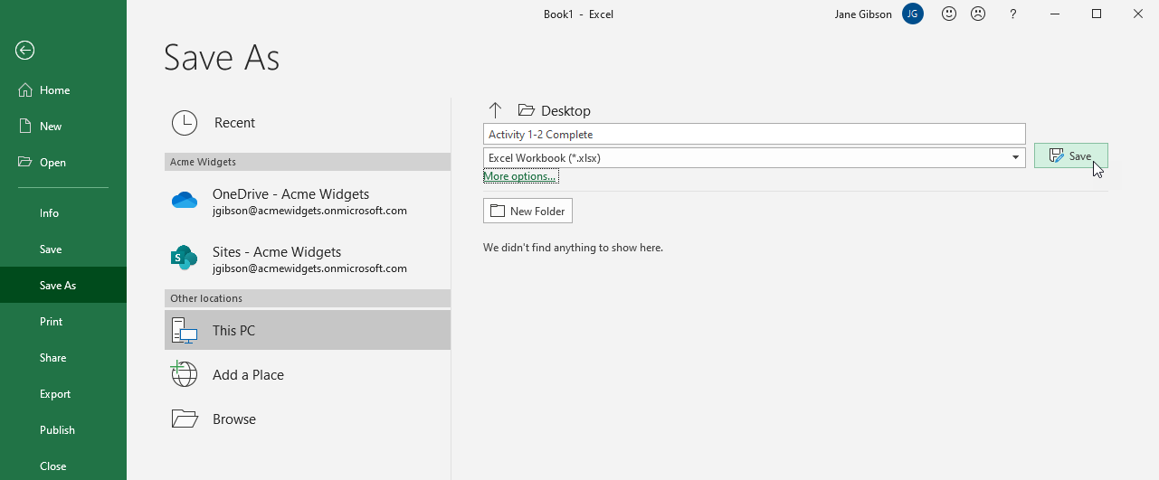

12. The workbook is now saved to your desktop:

13. Close Microsoft 365 Excel to complete this activity.

Exercise: Getting Help in Excel 365

**How to complete this exercise**

To complete this exercise, you will need access to Microsoft 365 Excel.

**Note:** Keep in mind that if you are using free Office for the web or another version of the Microsoft 365 Excel application some features covered in this exercise may not be available.​

**Free Office for the web**

If you do not have access to Microsoft 365 Excel, you can use Free Office for the web. This version of Office allows you to view and edit files in apps like Word, Excel, and PowerPoint. This free service is available to anyone with a Microsoft account.

**Access Microsoft Account**

[Log in to your Microsoft account.](https://account.microsoft.com/) Type the email, phone number, or Skype sign-in that you use for other services (Outlook, Office, etc.), then select Next. If you don't have a Microsoft account, you can select No account? Create one!

**Let's get started!**

You have created a worksheet that contains sales revenue results, by quarter, for your regional sales representatives. You will use Microsoft 365 Excel help features to total the sales results for the year.

1. Click on the link below to open the Microsoft Excel exercise document you can use to complete this exercise.

[Exercise: Getting Help in Excel](https://www.coursera.org/learn/microsoft-excel-fundamentals/resources/Rpmcx)

2. Click cell G2 to select it, then click inside the Search box in the Title bar and type “**sum**” to show the available help options:

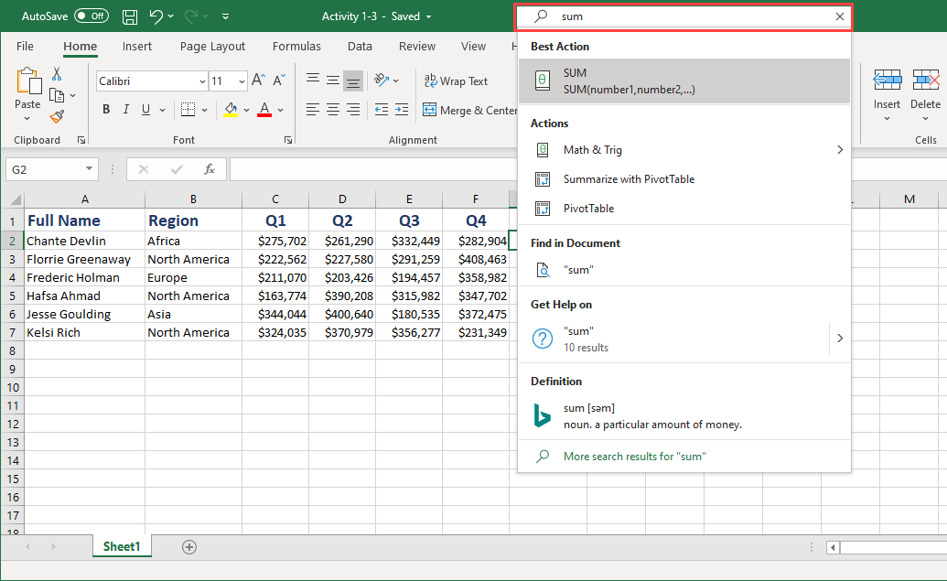

3. Click on **sum** under the heading **Get Help on**:

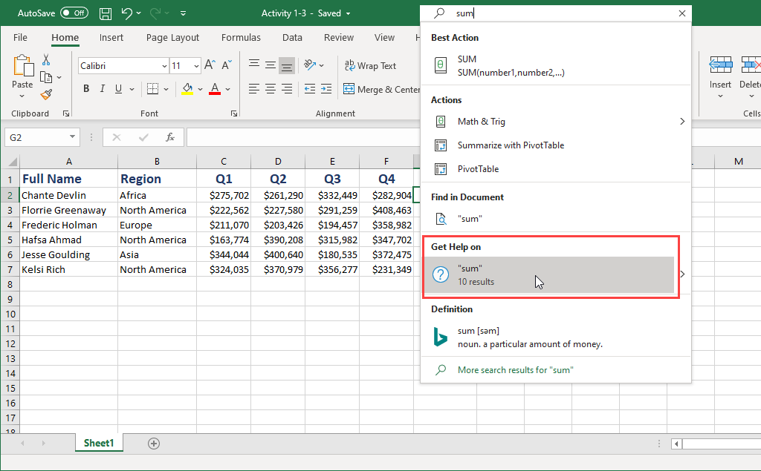

4. In the Help task pane that opens, read the instructions under the **Use the SUM function** heading to get information about an easy way to add the numbers in cells C2 through to F2:

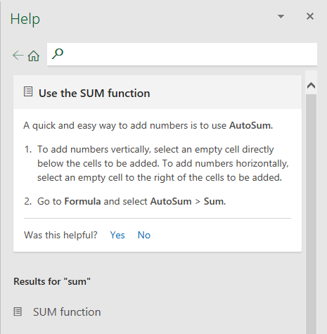

5. This will direct you to click **Formulas → AutoSum → Sum**:

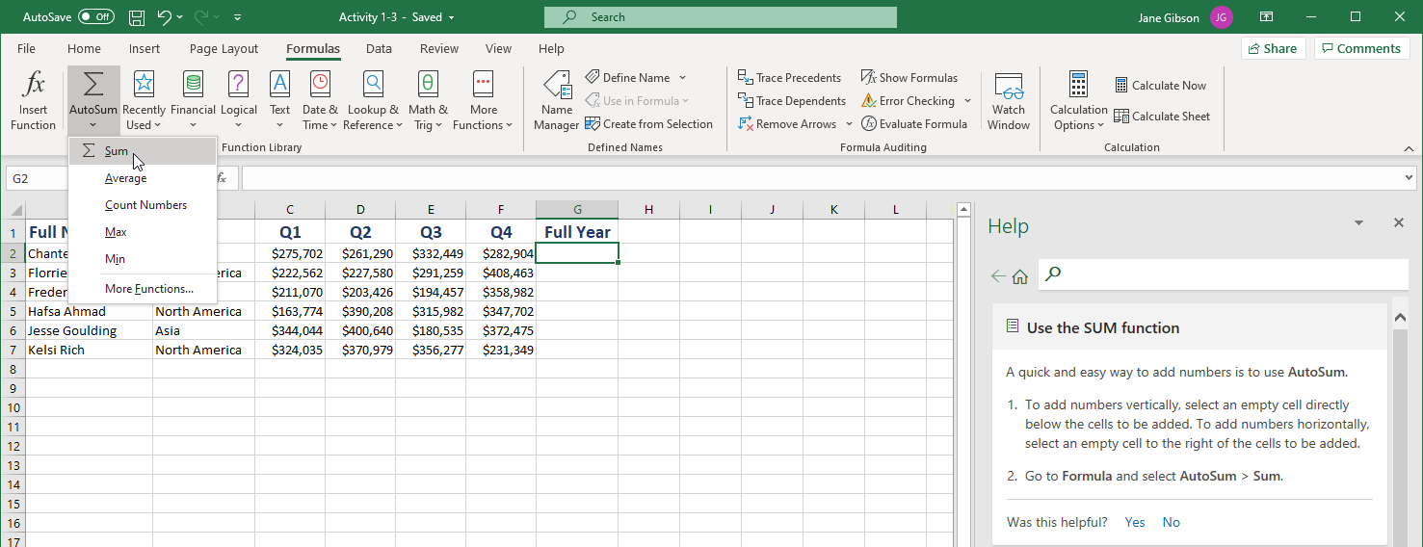

6. Press **Enter** to accept the formula. The sum will now be displayed in cell G2:

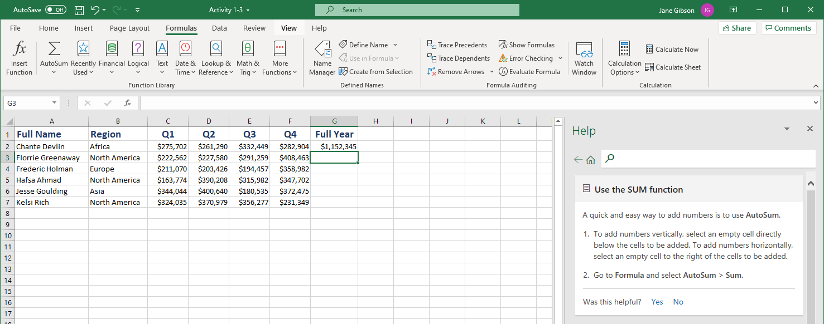

7. Now type “**copy formula down**” in the search field in the Help task pane. Select **copy formula down column** from the resulting options:

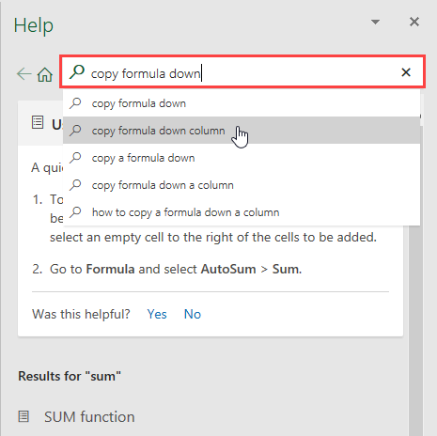

8. Read the instructions under the Copy cells heading to copy the formula in cell G2 to cells G3 through to G7:

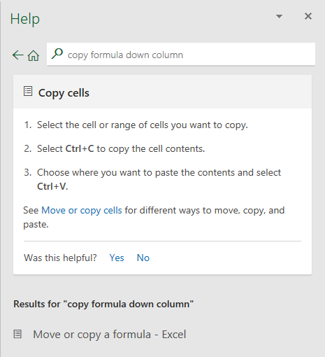

9. You will then select cell G2 and press **Ctrl + C**, to copy the formula, then select cells G3 through to G7 and press **Ctrl + V** to paste the formula:

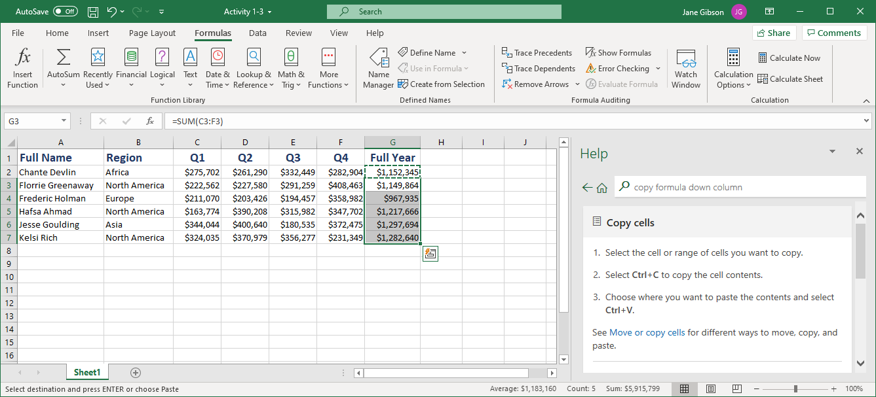

10. Select Cell G3 and note the structure of the formula in the Formula bar:

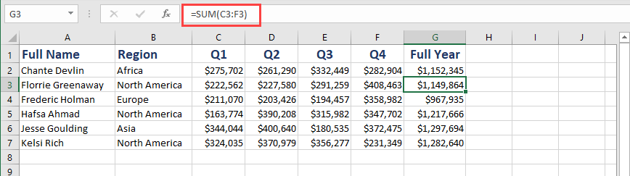

11. Now click on the **Help** tab in the ribbon, then click through the available help options to familiarize yourself with the available features:

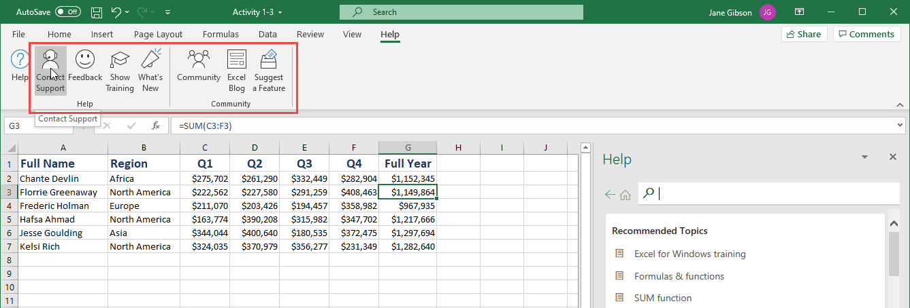

12. Save your workbook as Activity 1-3 Complete. Close Microsoft 365 Excel to complete this activity.

13. Now, you can check out an example of a completed document in the link below:

[Completed exercise: Getting Help in Excel 365](https://www.coursera.org/learn/microsoft-excel-fundamentals/resources/mhDXS)

## Exercise: Working with data

**How to complete this exercise**

To complete this exercise, you will need access to Microsoft 365 Excel.

**Note:** Keep in mind that if you are using free Office for the web or another version of the Microsoft 365 Excel application some features covered in this exercise may not be available.​

**Free Office for the web**

If you do not have access to Microsoft 365 Excel, you can use Free Office for the web. This version of Office allows you to view and edit files in apps like Word, Excel, and PowerPoint. This free service is available to anyone with a Microsoft account.

**Access Microsoft Account**

[Log in to your Microsoft account.](https://account.microsoft.com/) Type the email, phone number, or Skype sign-in that you use for other services (Outlook, Office, etc.), then select Next. If you don't have a Microsoft account, you can select No account? Create one!

**Let's get started!**

In this activity, you will use AutoFill and Flash Fill to complete the financial data workbook.

1. Click on the link below to open the Microsoft Excel exercise document you can use to complete this exercise.

[Exercise: Working with data](https://www.coursera.org/learn/microsoft-excel-fundamentals/resources/IqJcn)

2. First, let’s use AutoFill to complete the formulas for the two profit columns. First, select cell **G2** and place your cursor over the green **AutoFill** handle in the bottom right corner of the cell:

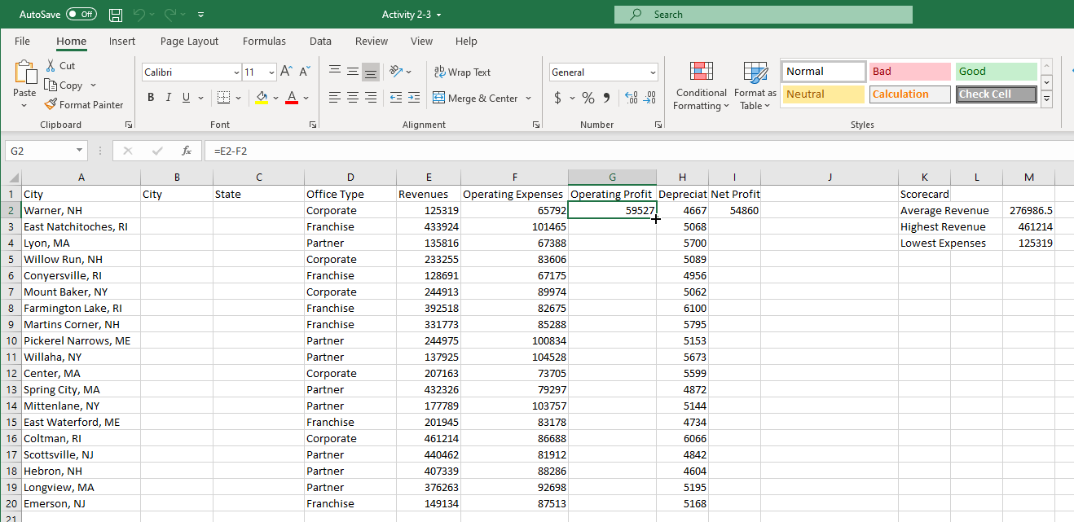

3. Click and drag it down to cell **G20**. This will copy the formula from G2 to all the blank cells, adjusting the cell references in the formula for each row:

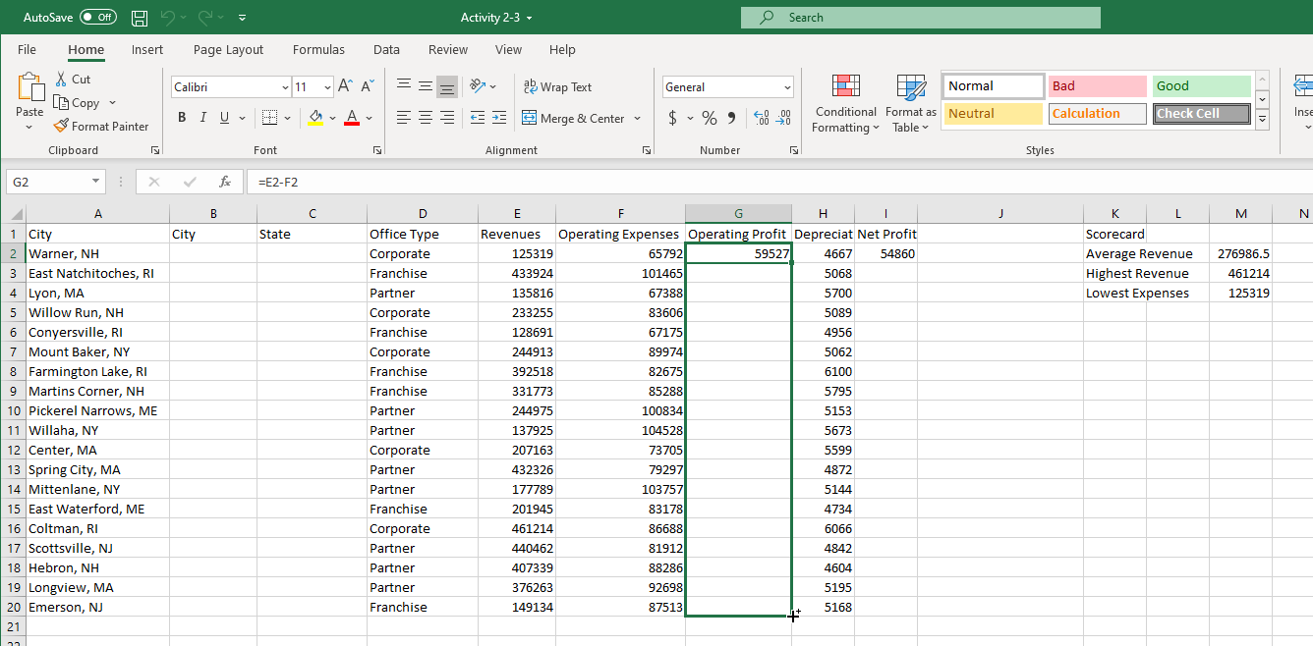

4. Observe the results:

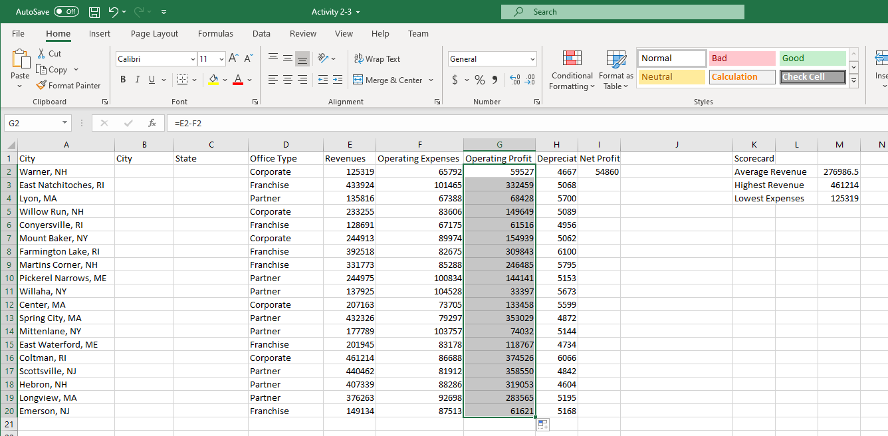

5. To extend the formula in column I, rather than clicking and dragging the AutoFill handle, simply double-click it. Note that Excel identifies the data pattern and copies the formulas to the end of the data in row 20:

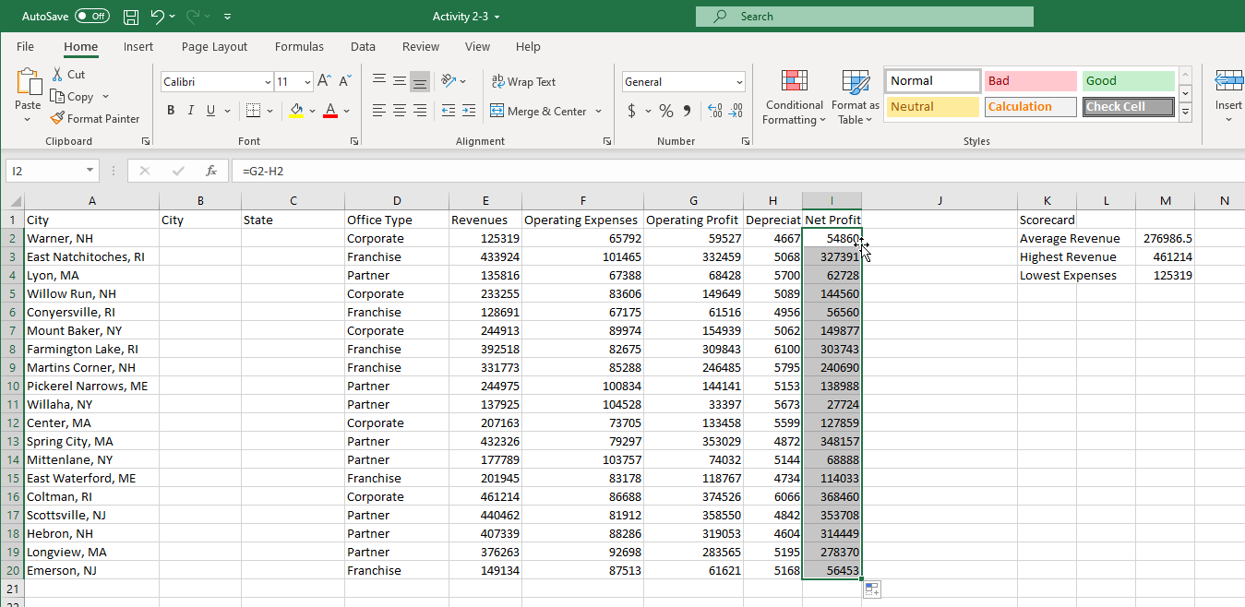

6. Now, use Flash Fill to separate the City and State data from column A into columns B and C. Click in cell **B2** and type the City name from cell A2, “**Warner**”, then click in cell C2 and type the State abbreviation “**NH**”:

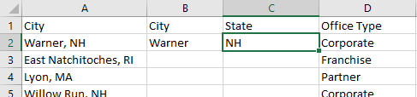

7. Now select cell B3, then click **Data → Flash Fill**:

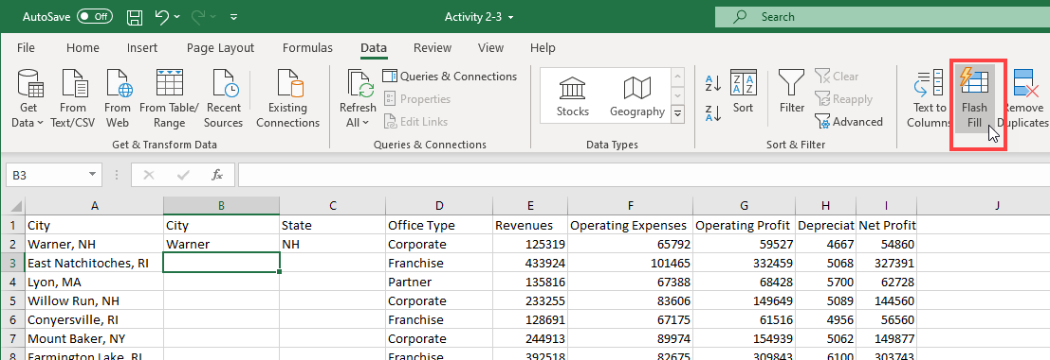

8. Cells B2 through B20 now contain only the city name from column A. Now click cell C3 and click **Data → Flash Fill** to repeat the process for the State abbreviations:

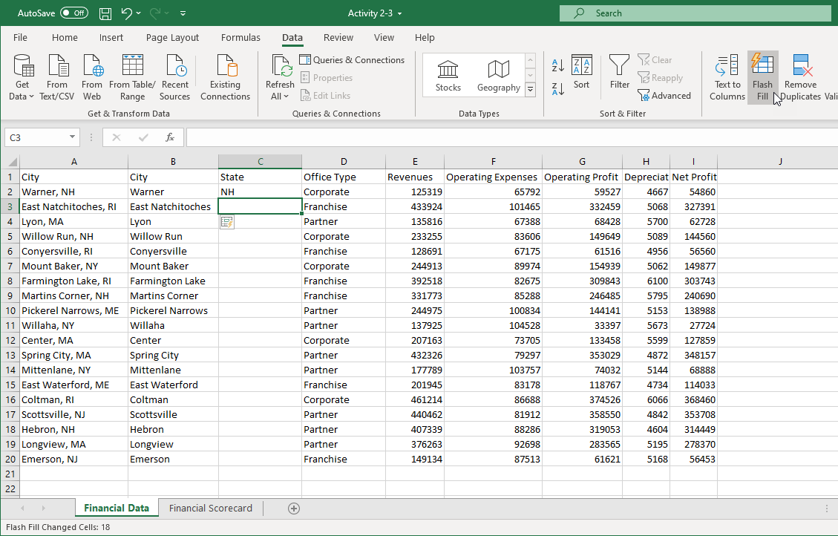

9. Observe the results:



10. You can now discard the data in column A by right-clicking on the column header and selecting **Delete** from the menu:

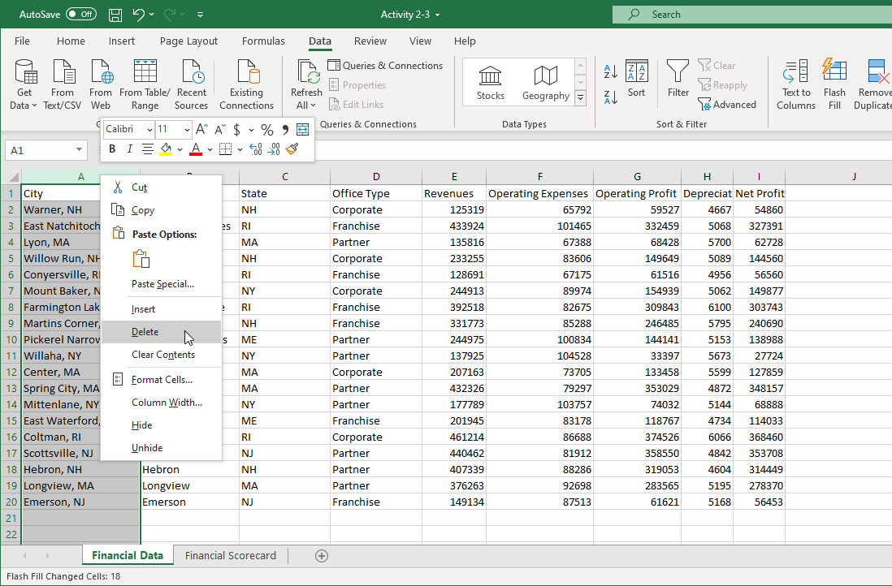

11. The data in column A is removed and the remaining data shifts one column to the left. Note that the cell references in your formulas have changed to the new column letters automatically:

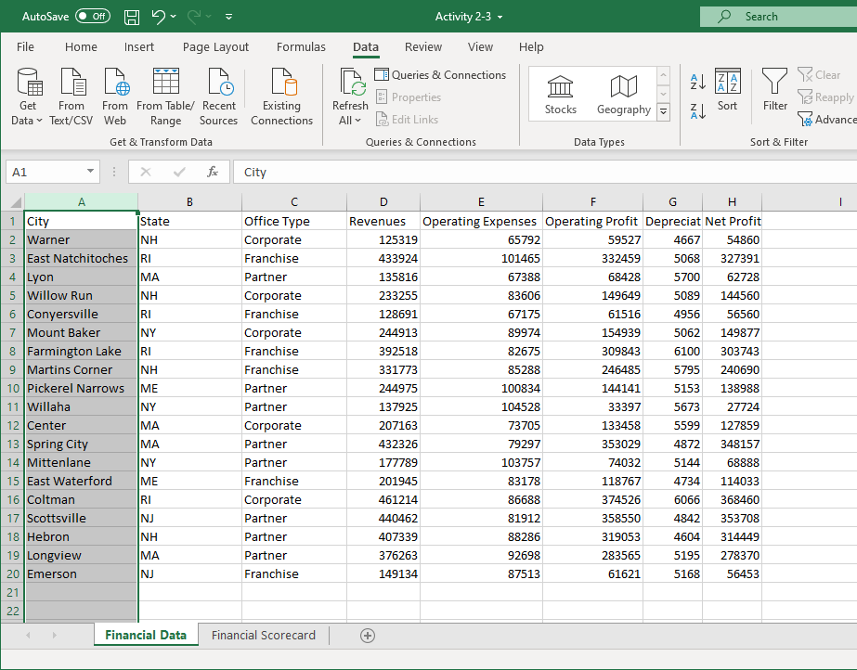

12. Finally, we need to copy the Scorecard data to its own sheet. Select cells **J1 through to L4** by clicking and dragging:



13. Click **Home → Copy**:

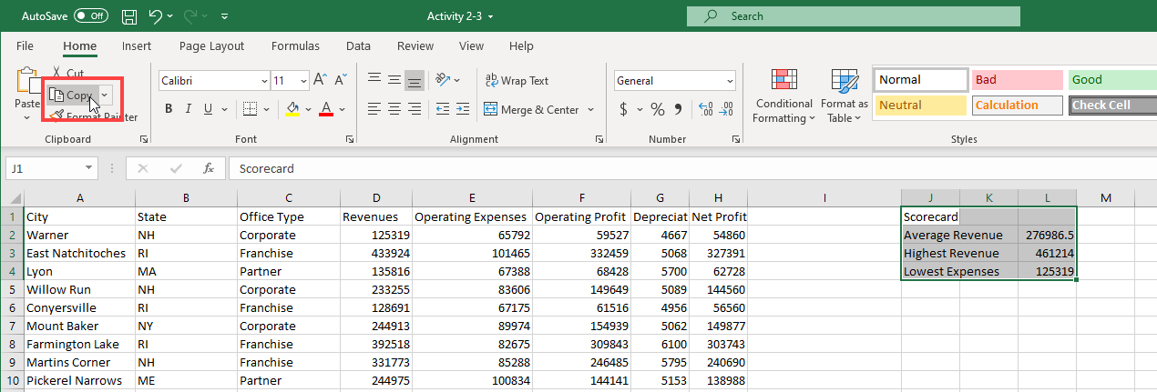

14. Click the **Financial Scorecard** worksheet tab:

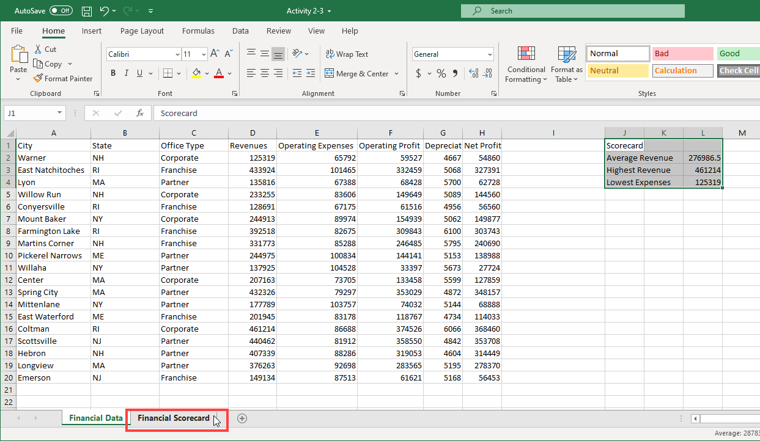

15. Ensure your cursor is in cell A1. Click the Home tab in the ribbon, click on the drop-down arrow of the Paste command, then click the **Paste Values** icon from the menu:

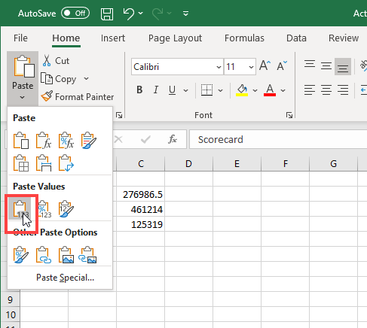

16. The data will be pasted:

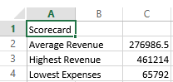

If you select one of the cells in Column C and click in the formula bar, you will notice that the formulas have been replaced by static values. This is because we selected the Values option to prevent the formulas from breaking during the copy process.

17. Save your workbook as Activity 2-3 Complete. Close Microsoft 365 Excel to complete this activity.

18. Now, you can check out an example of a completed document in the link below:

[Completed exercise: Working with data](https://www.coursera.org/learn/microsoft-excel-fundamentals/resources/hUgSv)

Exercise: Formatting cells

**Note**: You can pass this course and all graded assessments without access to the downloadable version of Excel.

**How to complete this exercise**

To complete this exercise, you will need access to Microsoft 365 Excel.

**Note:** Keep in mind that if you are using free Office for the web or another version of the Microsoft 365 Excel application some features covered in this exercise may not be available.​

**Free Office for the web**

If you do not have access to Microsoft 365 Excel, you can use Free Office for the web. This version of Office allows you to view and edit files in apps like Word, Excel, and PowerPoint. This free service is available to anyone with a Microsoft account.

**Access Microsoft Account**

[Log in to your Microsoft account.](https://account.microsoft.com/) Type the email, phone number, or Skype sign-in that you use for other services (Outlook, Office, etc.), then select Next. If you don't have a Microsoft account, you can select No account? Create one!

**Let's get started!**

In this activity, you will improve the appearance and readability of your sales report using borders, fills, and number formatting.

1. Click on the link below to open the Microsoft Excelexercise document you can use to complete this exercise.

[Exercise: Formatting cells](https://www.coursera.org/learn/microsoft-excel-fundamentals/resources/GXq4p)

2. First, let’s apply the proper formatting to our data. The Financial Scorecard worksheet should be open. (If not, click its tab to switch to it.) Select the **three cells containing numbers in Column B**:

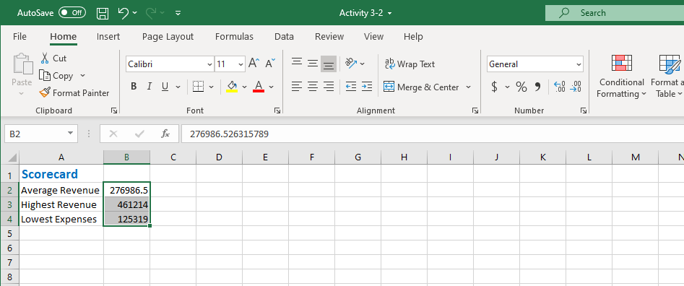

3. Click the **dollar icon** in the Number group of the Home tab and click **$ English (United States)**:

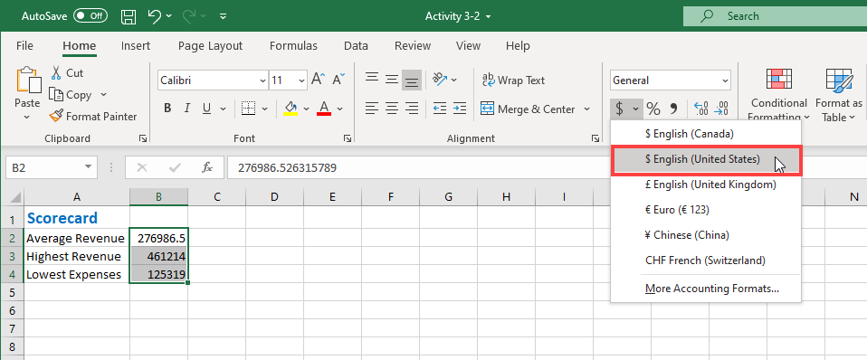

4. The formatting will be applied. However, we do not need the cents information, so click **Decrease Decimal** twice:

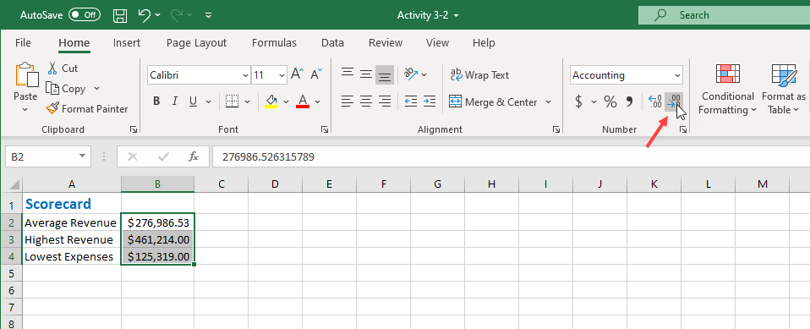

5. This will remove the decimals from the numbers, but notice that the full value is still available in the formula bar:

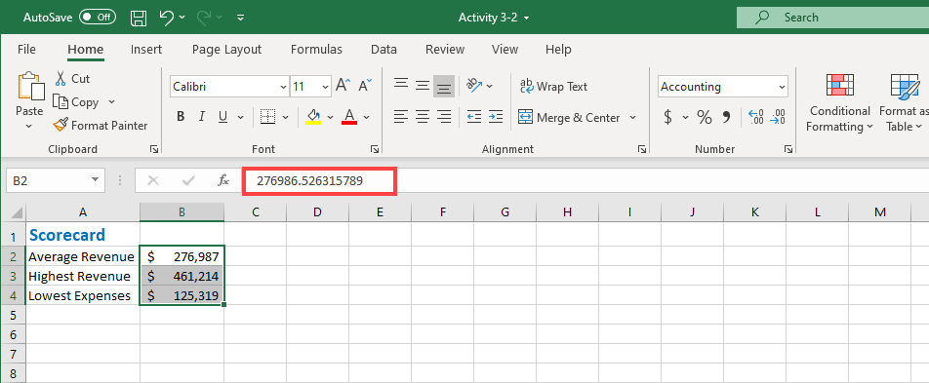

6. Now, switch to the **Financial Data** worksheet:

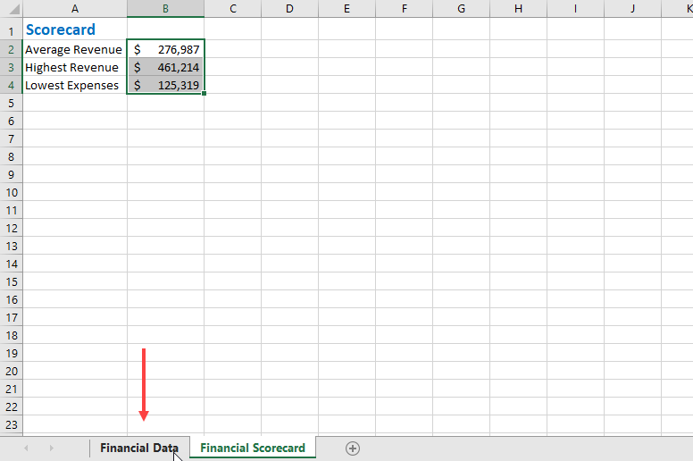

7. Select cells **D3 through H20**:

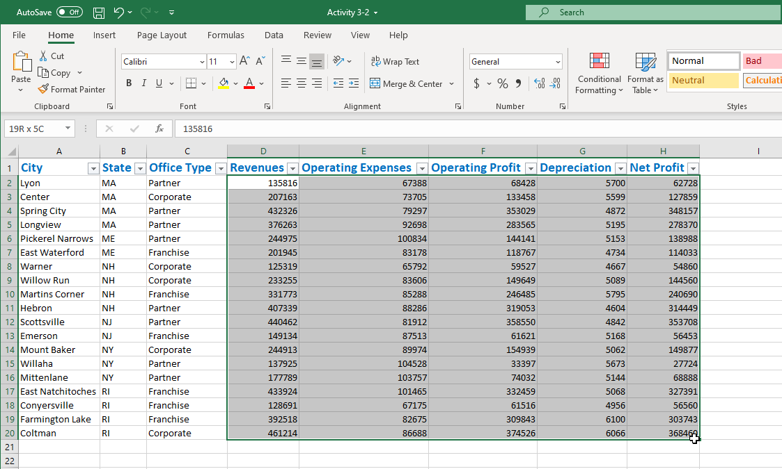

8. Click the **dollar icon** in the Number group of the Home tab and click **$ English (United States)**:

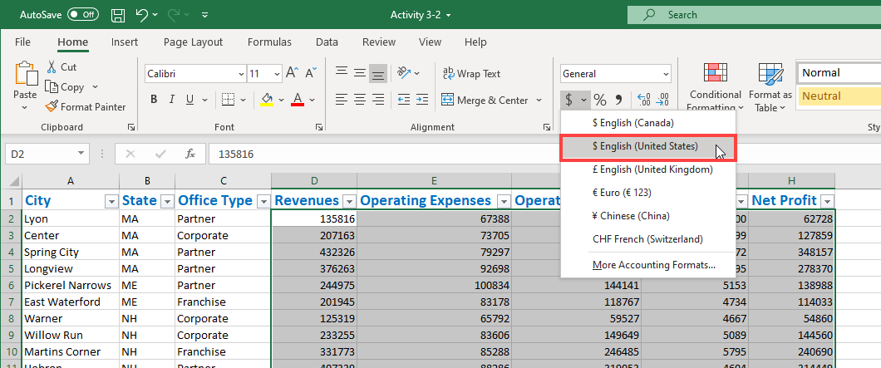

9. Click the **Decrease Decimal** button twice to remove the cents values:

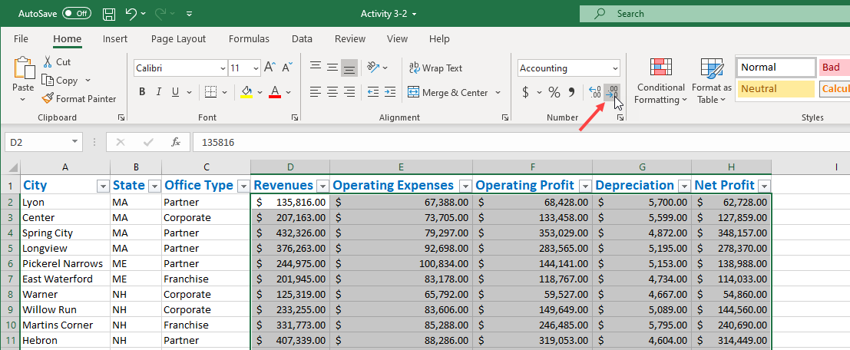

10. Review the results:

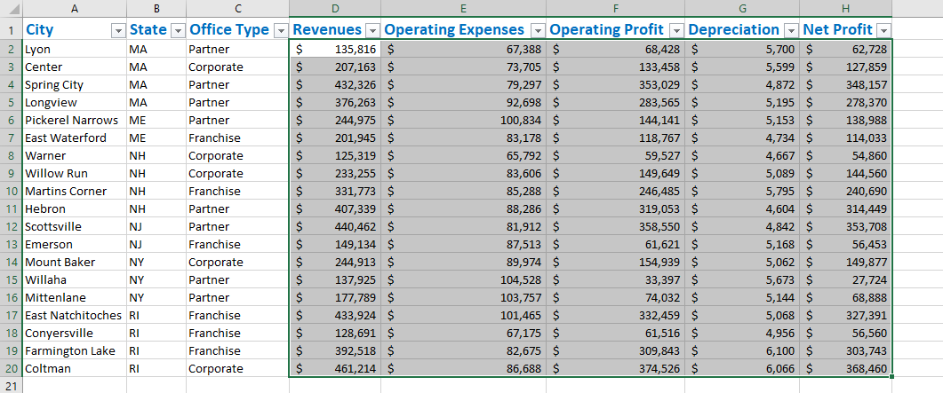

11. Finally, let’s make the header row stand out a bit more. Select cells **A1 to H1**:

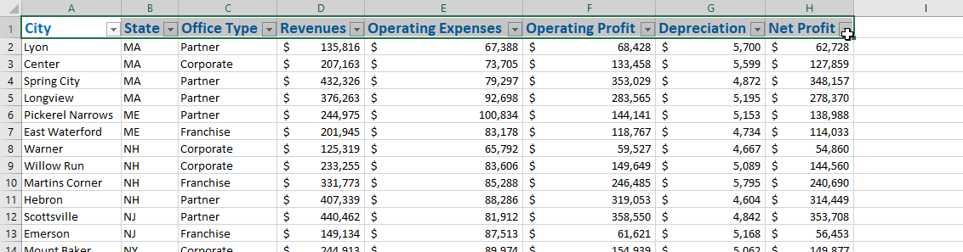

12. Click the **Borders drop-down arrow** and click **Thick Bottom Border**:

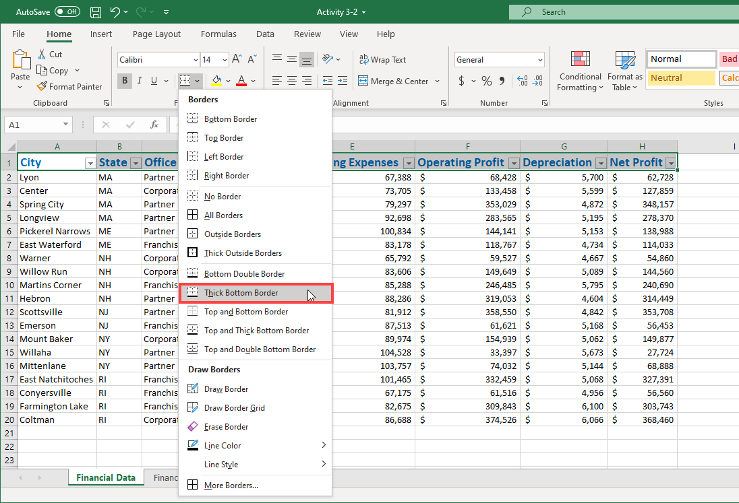

13. The border will be added. Now, click the Fill drop-down arrow and choose the color shown here:

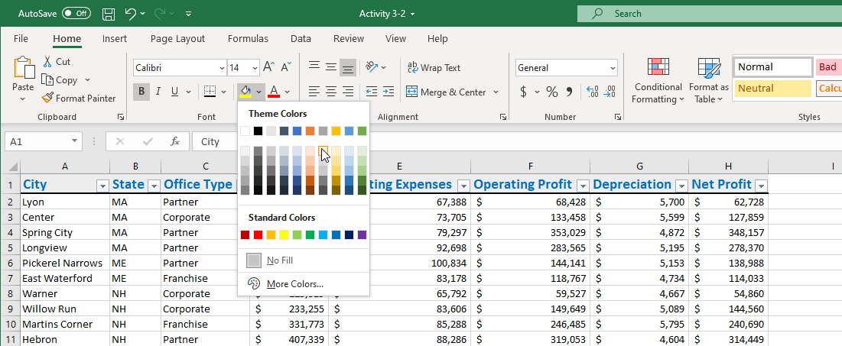

14. Click **any cell** to de-select the header row. Review your formatting changes:

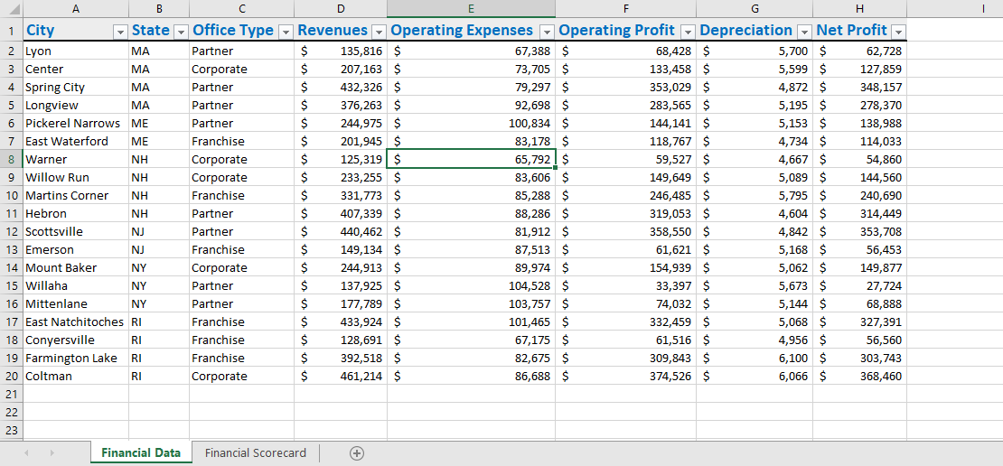

15. Save your workbook as Activity 3-2 Complete. Close Microsoft 365 Excel to complete this activity.

16. Now, you can check out an example of a completed document in the link below:

[Completed exercise: Formatting cells](https://www.coursera.org/learn/microsoft-excel-fundamentals/resources/gZBvs)

Exercise: Aligning cell content

**Note**: You can pass this course and all graded assessments without access to the downloadable version of Excel.

**How to complete this exercise**

To complete this exercise, you will need access to Microsoft 365 Excel.

**Note:** Keep in mind that if you are using free Office for the web or another version of the Microsoft 365 Excel application some features covered in this exercise may not be available.​

**Free Office for the web**

If you do not have access to Microsoft 365 Excel, you can use Free Office for the web. This version of Office allows you to view and edit files in apps like Word, Excel, and PowerPoint. This free service is available to anyone with a Microsoft account.

**Access Microsoft Account**

[Log in to your Microsoft account.](https://account.microsoft.com/) Type the email, phone number, or Skype sign-in that you use for other services (Outlook, Office, etc.), then select Next. If you don't have a Microsoft account, you can select No account? Create one!

**Let's get started!**

In this activity, you will use alignment tools to improve the appearance of your financial data worksheet.

1. Click on the link below to open the Microsoft Excel exercise document you can use to complete this exercise.

[Exercise: Aligning cell content](https://www.coursera.org/learn/microsoft-excel-fundamentals/resources/GjRez)

2. First, select columns D through H:

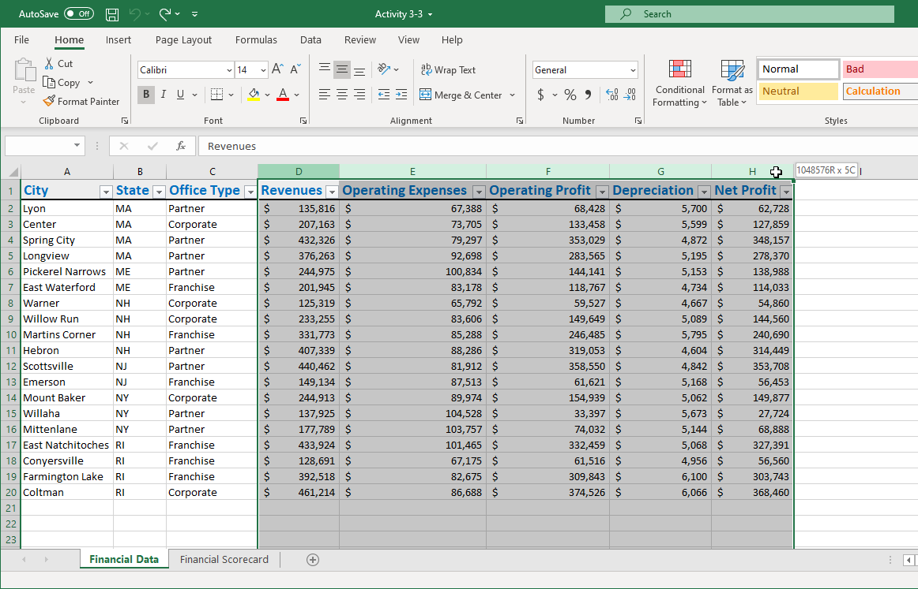

3. Click the **Format drop-down arrow** in the **Cells** group of the Home tab:

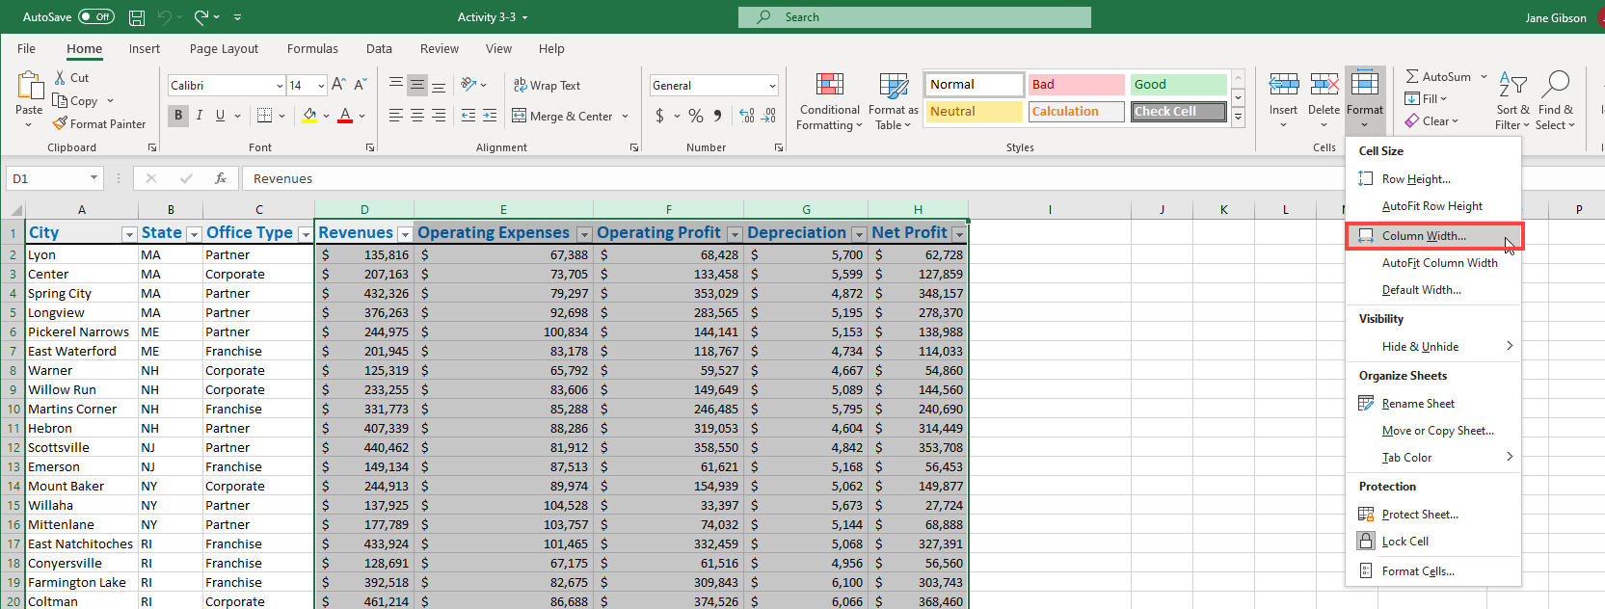

4. Enter **15** in the **Column width** field of the Column Width dialog box, then click **OK**:

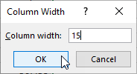

5. Now, select **Row 1**, then click **Home → Wrap Text**:

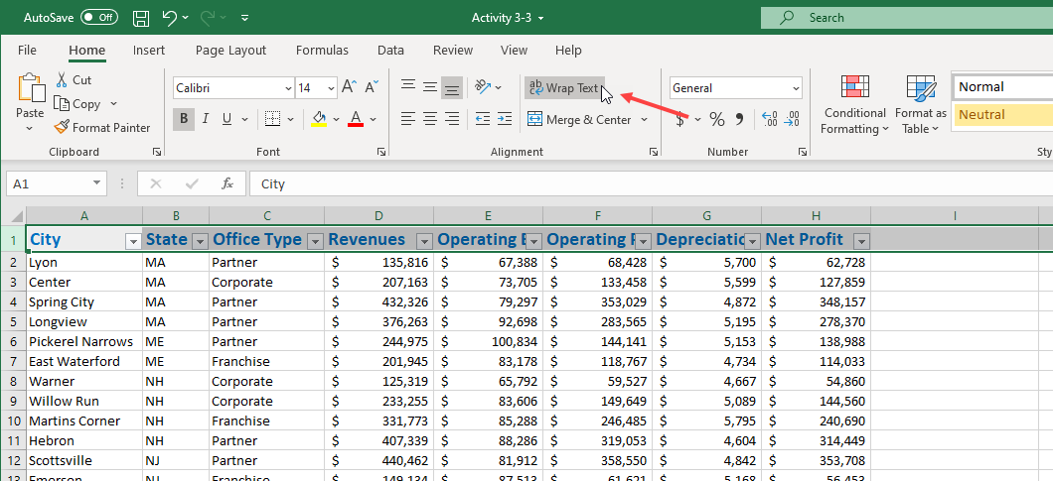

6. Click the **Middle Align** button in the Alignment group of the Home tab:

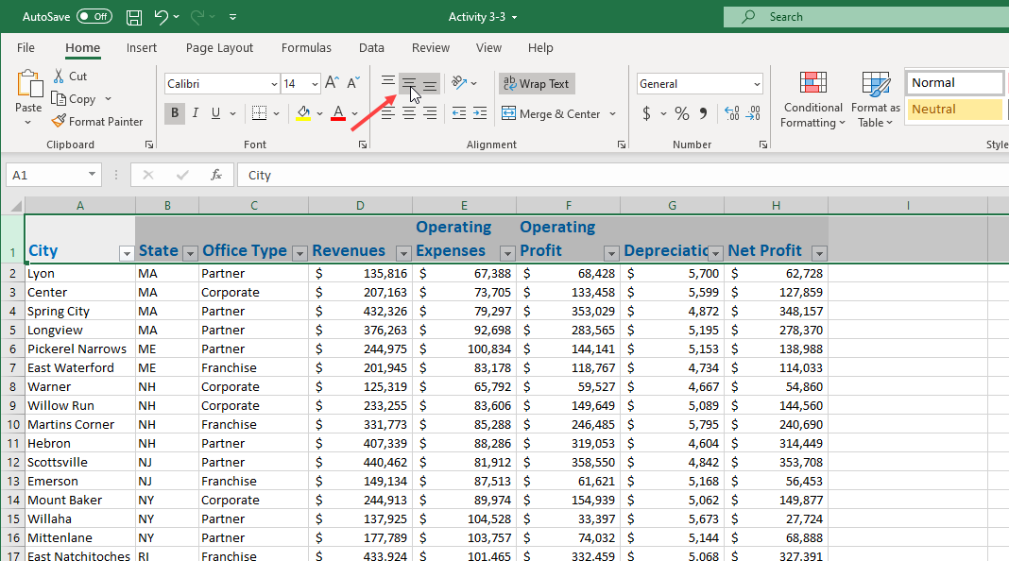

7. Now select cells **D1 through H1** and click the **Center** button:

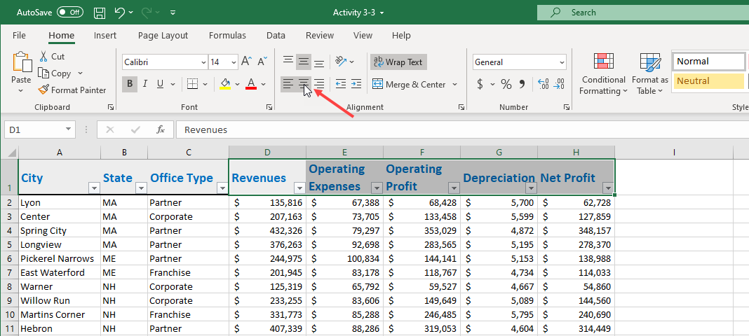

8. Now that the financial data is neatly arranged with a well-formatted header row, select cells **A1 through C20**, then click the **Increase** **Indent** button:

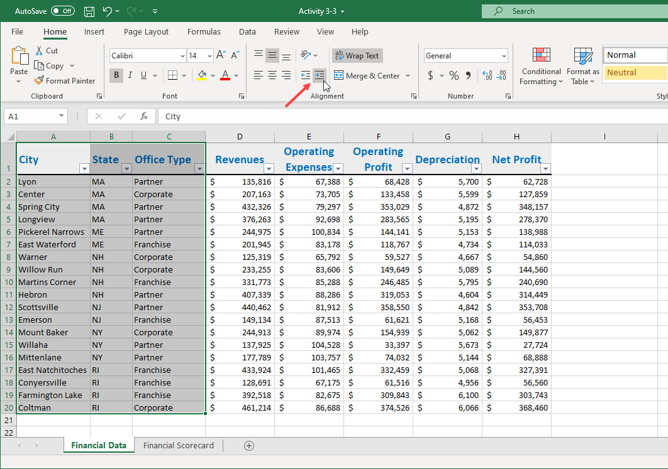

9. To adjust the cell width, click **Home** → **Format drop-down arrow → AutoFit Column Width**:

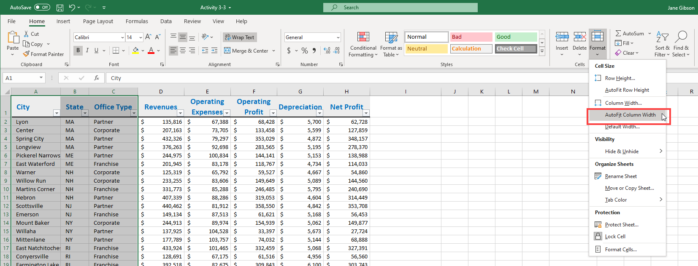

10. Now select cell **A1** and click **Home → Format Painter**, to copy the cell formatting. Once done, switch to the **Financial Scorecard** worksheet:

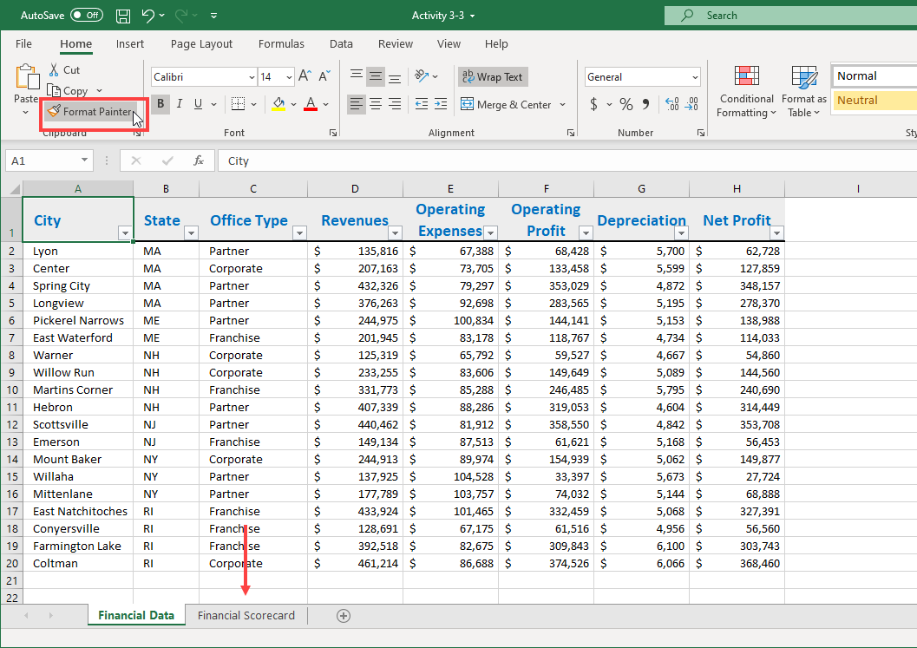

11. Click on cell **A1** to apply the format:

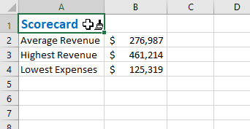

12. Finally, select cells **A1 through B1**, then click **Home →Merge & Center**:

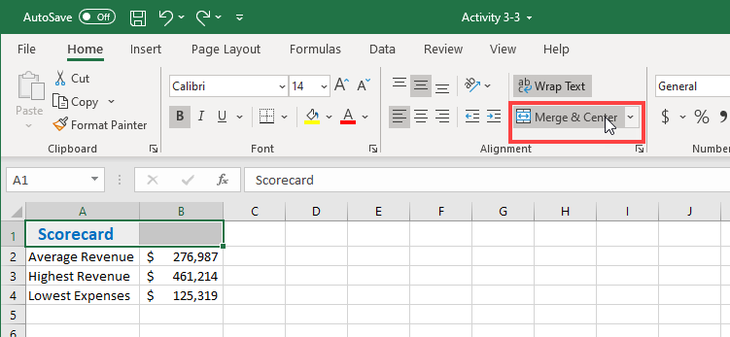

13. The cells are now merged and centered, and the formatting from cell A1 has also been applied to cell B1:

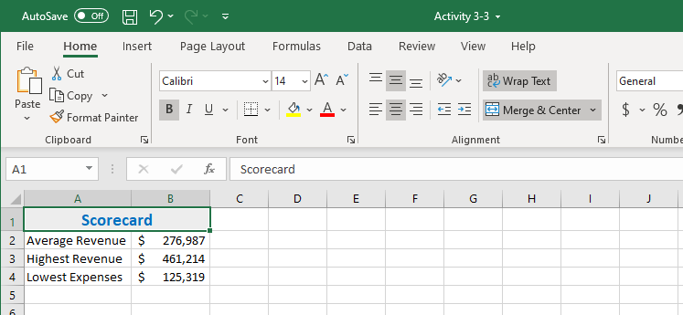

14. Save your workbook as Activity 3-3 Complete. Close Microsoft 365 Excel to complete this activity.

15. Now, you can check out an example of a completed document in the link below:

[Completed exercise: Aligning cell content](https://www.coursera.org/learn/microsoft-excel-fundamentals/resources/QcJSQ)

Exercise: Searching for and replacing data

**Note**: You can pass this course and all graded assessments without access to the downloadable version of Excel.

**How to complete this exercise**

To complete this exercise, you will need access to Microsoft 365 Excel.

**Note:** Keep in mind that if you are using free Office for the web or another version of the Microsoft 365 Excel application some features covered in this exercise may not be available.​

**Free Office for the web**

If you do not have access to Microsoft 365 Excel, you can use Free Office for the web. This version of Office allows you to view and edit files in apps like Word, Excel, and PowerPoint. This free service is available to anyone with a Microsoft account.

**Access Microsoft Account**

[Log in to your Microsoft account.](https://account.microsoft.com/) Type the email, phone number, or Skype sign-in that you use for other services (Outlook, Office, etc.), then select Next. If you don't have a Microsoft account, you can select No account? Create one!

**Let's get started!**

You have been asked to make some changes to the Sales Report. Rather than manually changing every cell you decide to use the Find and Replace tool.

1. Click on the link below to open the Microsoft Excel exercise document you can use to complete this exercise.

[Exercise: Searching for and replacing data](https://www.coursera.org/learn/microsoft-excel-fundamentals/resources/HM9l3)

2. First, you need to replace all of the forward slashes separating the countries and regions with a hyphen. Click **Home → Find & Select → Replace**:

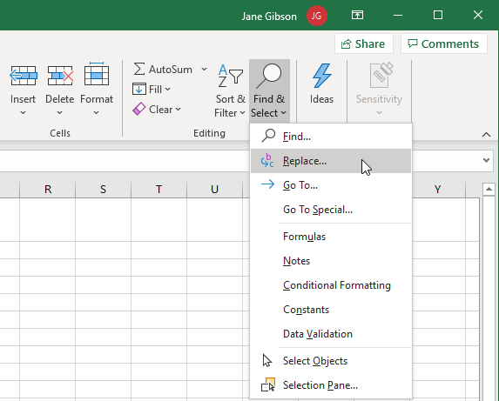

3. Type the forward-slash character (“**/**”) in the “Find what” field, type space, hyphen, space (“ **–** “), in the “Replace with” field, then click **Replace All**:

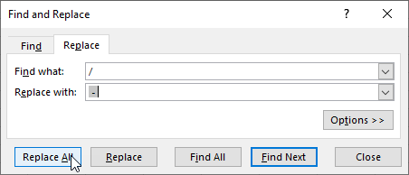

4. An information dialog box will appear indicating that the operation is complete, and 20 replacements were made. Click **OK**:

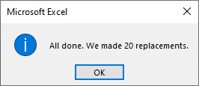

5. Now click on the **Email Addresses** tab:

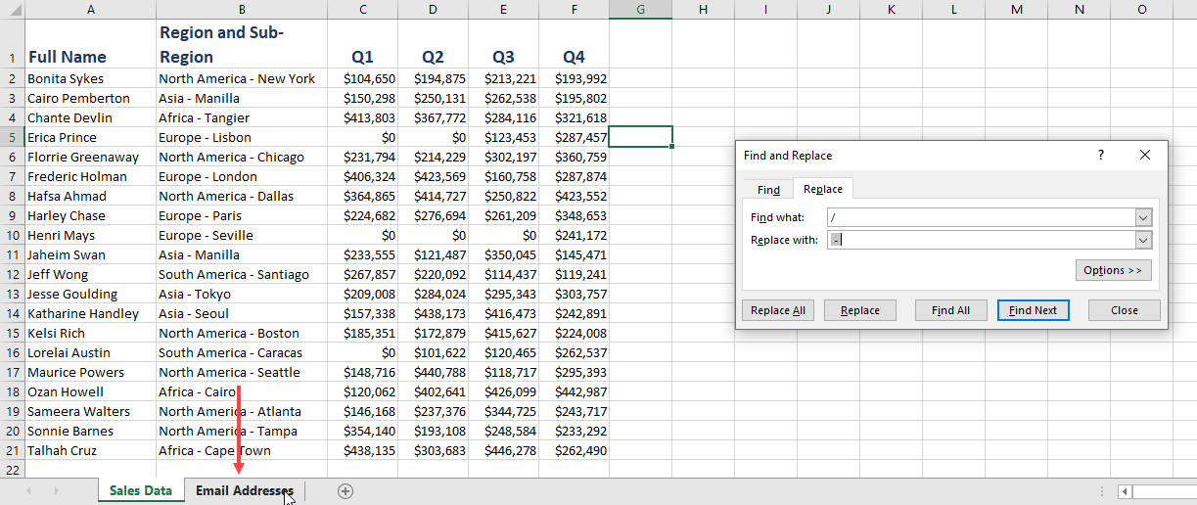

6. Notice that the forward slashes on this sheet have not been replaced. Click on the **Sales Data** tab to return to that sheet:

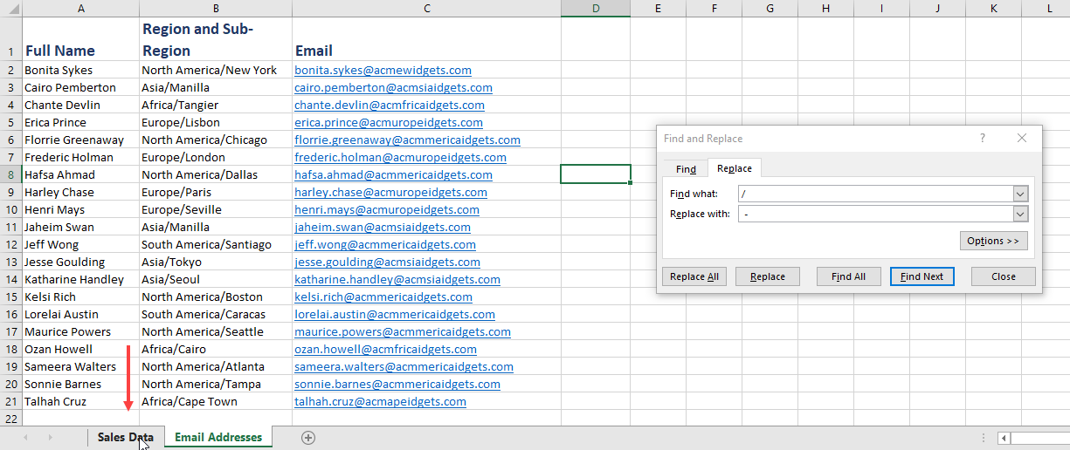

7. Now Click the **Options** button in the Find and Replace dialog box, select **Workbook** from the **Within** drop-down menu, then click **Replace All**:

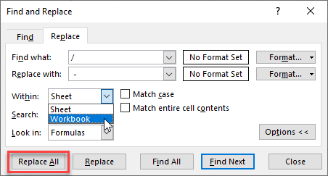

8. Note that the Information dialog box now reports that another 20 replacements have been made, this time on the Email Addresses sheet:

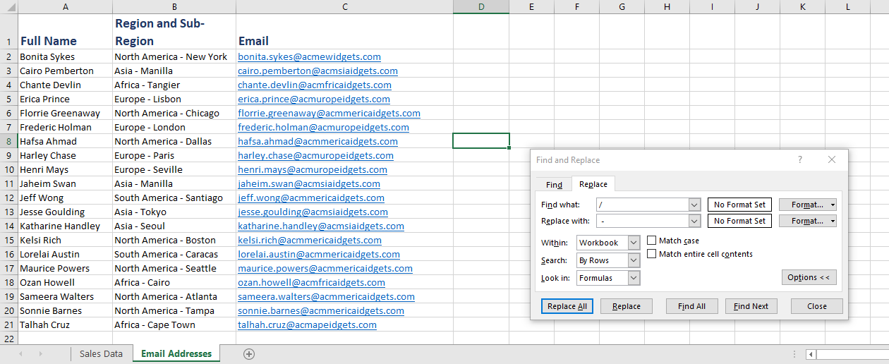

9. The next task is to remove any values of zero from the quarterly sales numbers. Switch back to the Sales Data worksheet and replace the contents of the **Find what** field with a zero (“**0**”). Next, select the contents of the **Replace with** field and press **Delete**. Finally, click **Replace All**:

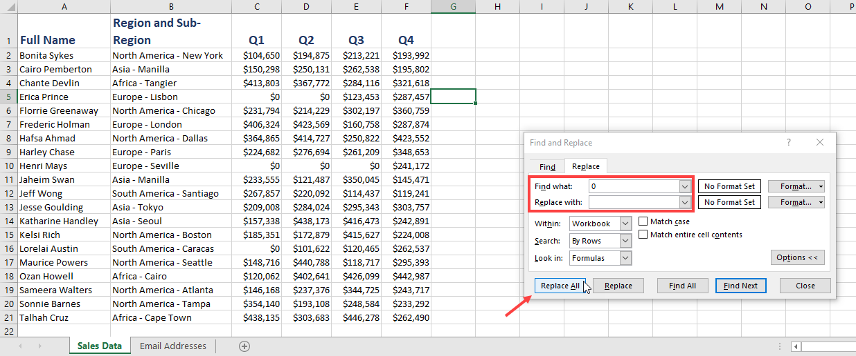

10. Once you have clicked **OK** to acknowledge the 40 replacements, note that the cells with a value of zero been replaced, and any zeros in the quarterly sales values have also been removed:

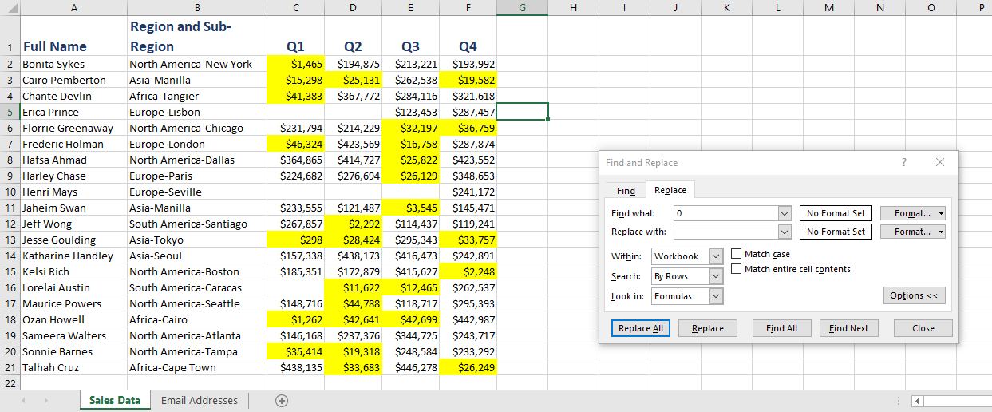

11. Click the **Undo drop-down** arrow on the Quick Access toolbar and select the most recent **replace** action to restore the correct data:

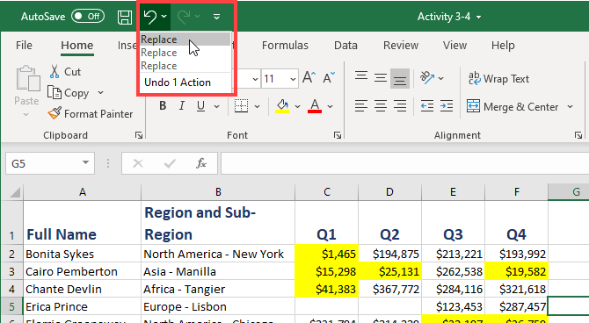

12. Now click to select the **Match entire cell contents** checkbox and, once again, click **Replace All**:

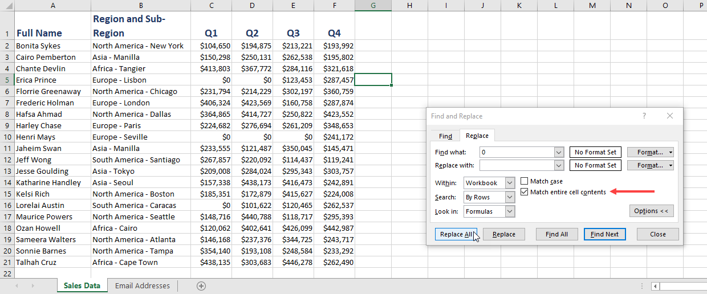

13. Now only the six cells that have a zero as the entire cell contents have been replaced:

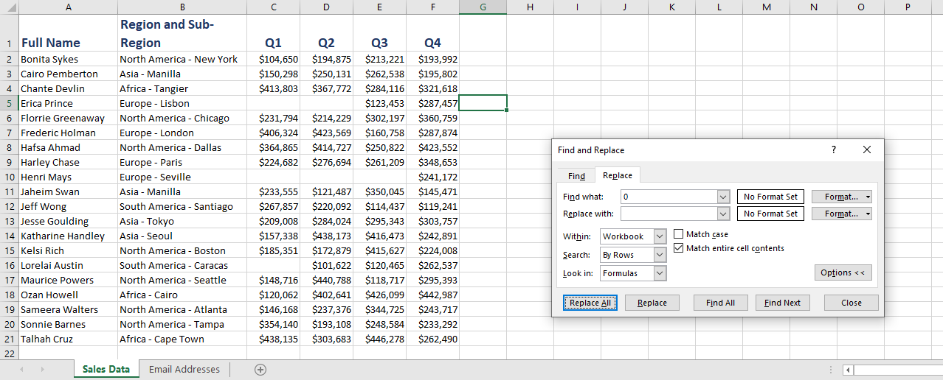

14. Click Close to close the Find and Replace dialog box, then save your workbook as Activity 3-4 Complete. Close Microsoft 365 Excel to complete this activity.

15. Now, you can check out an example of a completed document in the link below:

[Completed exercise: Searching for and replacing data](https://www.coursera.org/learn/microsoft-excel-fundamentals/resources/8ABXU)

Exercise: Spell checking a worksheet

**Note**: You can pass this course and all graded assessments without access to the downloadable version of Excel.

**How to complete this exercise**

To complete this exercise, you will need access to Microsoft 365 Excel.

**Note:** Keep in mind that if you are using free Office for the web or another version of the Microsoft 365 Excel application some features covered in this exercise may not be available.​

**Free Office for the web**

If you do not have access to Microsoft 365 Excel, you can use Free Office for the web. This version of Office allows you to view and edit files in apps like Word, Excel, and PowerPoint. This free service is available to anyone with a Microsoft account.

**Access Microsoft Account**

[Log in to your Microsoft account.](https://account.microsoft.com/) Type the email, phone number, or Skype sign-in that you use for other services (Outlook, Office, etc.), then select Next. If you don't have a Microsoft account, you can select No account? Create one!

**Let's get started!**

You would like to review your sales report for any spelling errors.

1. Click on the link below to open the Microsoft Excel exercise document you can use to complete this exercise.

[Exercise: Spell Checking a Worksheet](https://www.coursera.org/learn/microsoft-excel-fundamentals/resources/4tlUh)

2. Ensure that you are on the first worksheet of the workbook. Click **Review → Spelling**:

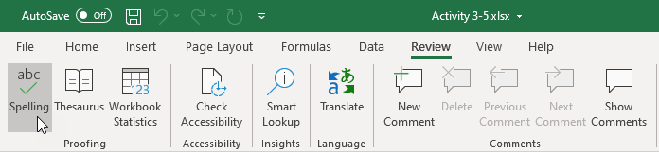

3. The word “Asia” is spelled incorrectly. The Spelling dialog box has selected the correct spelling, so click **Change** to continue:

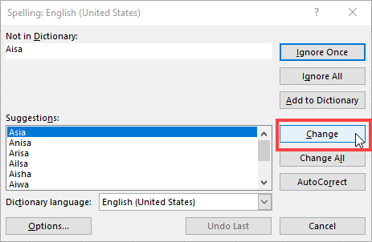

4. Correct the following errors, for “Tangier” and “Santiago” and the remaining instances of “Asia” in the same way:

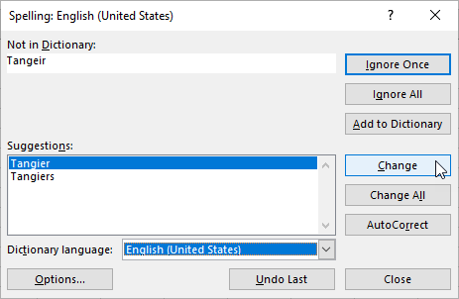

5. Click **Add to Dictionary** when you reach the spelling suggestions for the proper names “Sonnie” and “Talhah”:

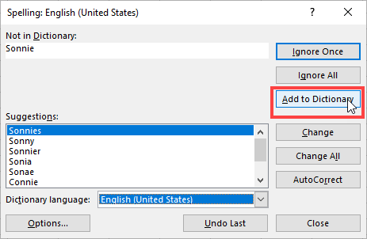

6. When Excel has finished checking the current sheet, click **OK** to close the spell checker:

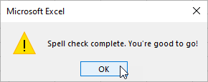

7. Now let’s check the **Email Addresses** sheet. Switch to it by clicking its tab:

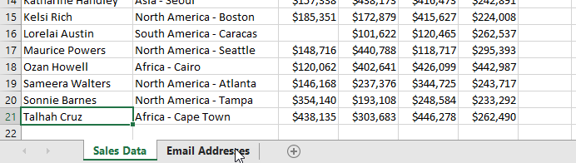

8. Press **F7** to check this sheet. Click **Change All** to correct all the instances of “Aisa”:

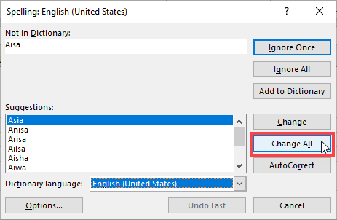

9. If you are prompted to start checking at the beginning of the sheet, click **Yes**:

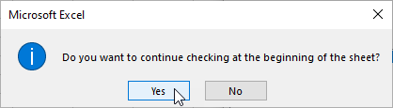

10. You will see a dialog box stating the spell checking is complete. Note that you were not asked to review both the proper names “Sonnie” and “Talhah” because they are now included in the dictionary. Click **OK** to continue:

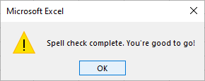

11. Click Close to **close** the Find and Replace dialog box, then save your workbook as Activity 3-5 Complete. Close Microsoft 365 Excel to complete this activity.

12. Now, you can check out an example of a completed document in the link below:

[Completed exercise: Spell Checking a Worksheet](https://www.coursera.org/learn/microsoft-excel-fundamentals/resources/PphIj)

Exercise: Previewing a workbook before printing

**Note**: You can pass this course and all graded assessments without access to the downloadable version of Excel.

**How to complete this exercise**

To complete this exercise, you will need access to Microsoft 365 Excel.

**Note:** Keep in mind that if you are using free Office for the web or another version of the Microsoft 365 Excel application some features covered in this exercise may not be available.​

**Free Office for the web**

If you do not have access to Microsoft 365 Excel, you can use Free Office for the web. This version of Office allows you to view and edit files in apps like Word, Excel, and PowerPoint. This free service is available to anyone with a Microsoft account.

**Access Microsoft Account**

[Log in to your Microsoft account.](https://account.microsoft.com/) Type the email, phone number, or Skype sign-in that you use for other services (Outlook, Office, etc.), then select Next. If you don't have a Microsoft account, you can select No account? Create one!

**Let's get started!**

A large workbook that you have been working with needs to be printed out. Before you do so, you need to ensure that everything will fit on the printed pages.

1. Click on the link below to open the Microsoft Excel exercise document you can use to complete this exercise.

[Exercise: Previewing a Workbook Before Printing](https://www.coursera.org/learn/microsoft-excel-fundamentals/resources/M8HK4)

2. Click **File → Print**:

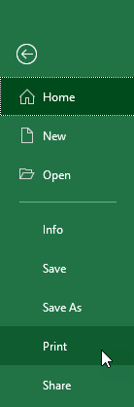

3. With the Print category now open in the Backstage view, you will see a preview of the current worksheet:

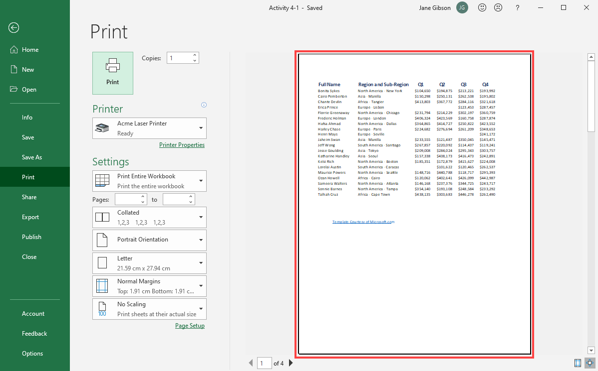

4. Right now, only the currently displayed worksheet will be printed. Within the Settings section, click **Print Active Sheets → Print Entire Workbook**:

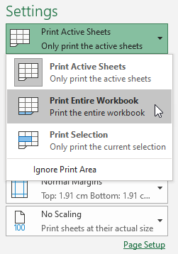

5. In the bottom left-hand corner of the preview area, click the **Next Page** button:

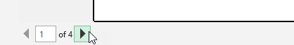

6. The second worksheet in the workbook is now displayed:

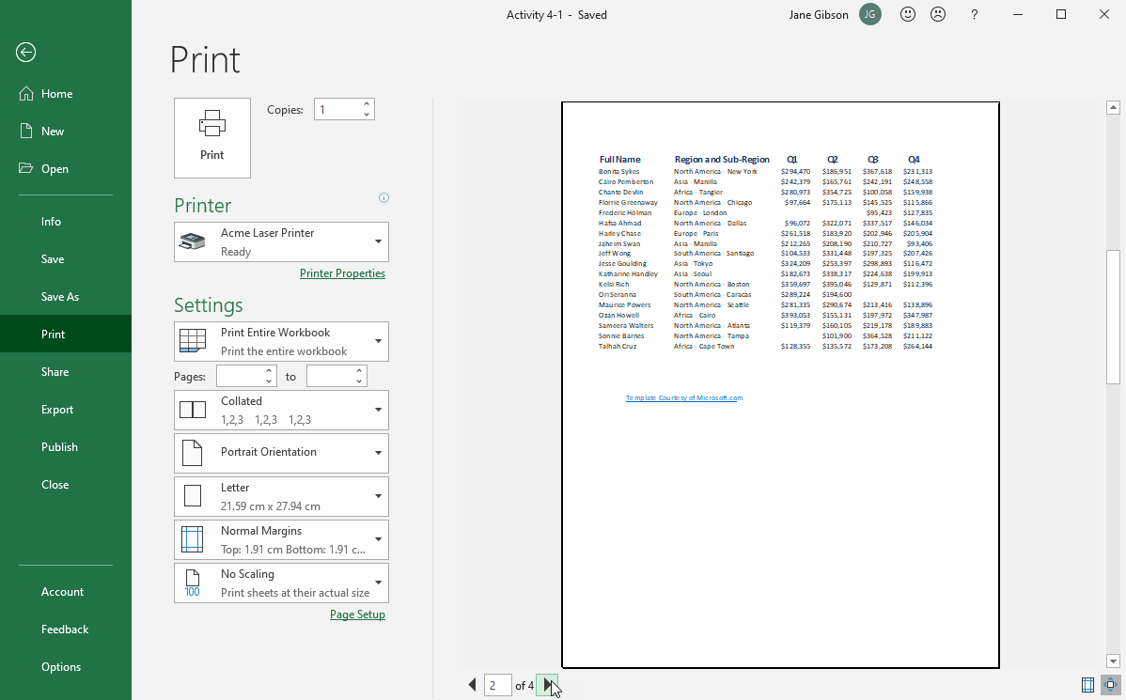

7. Click the Next Page button until you reach **page 4**. Note that the third sheet does not fit within the defined page boundaries and has flowed to a fourth page:

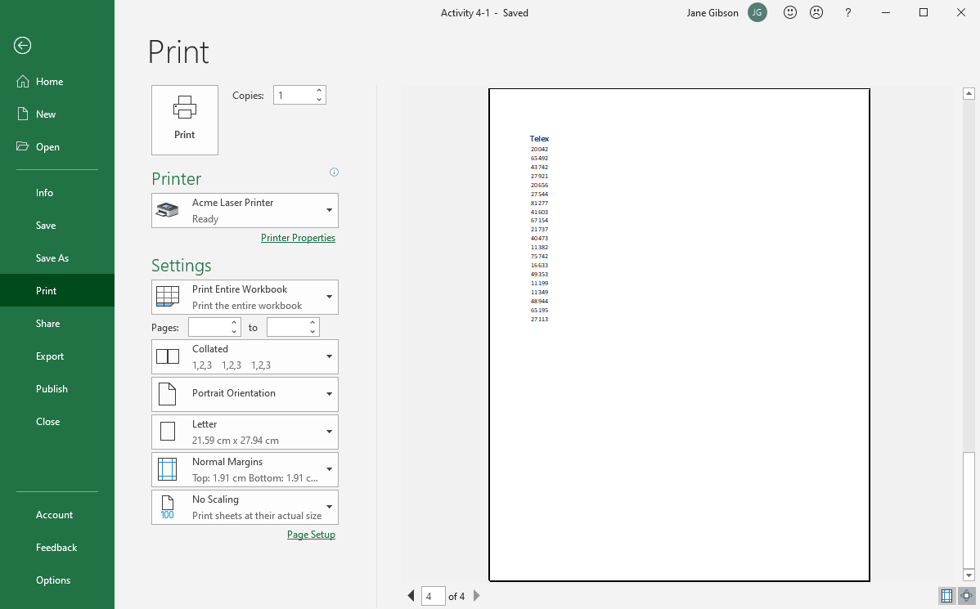

8. Within the Settings section, click **Portrait Orientation → Landscape Orientation**:

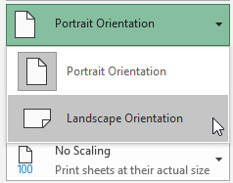

9. The page orientation is now landscape and the print preview is now displaying page 3 of 3:

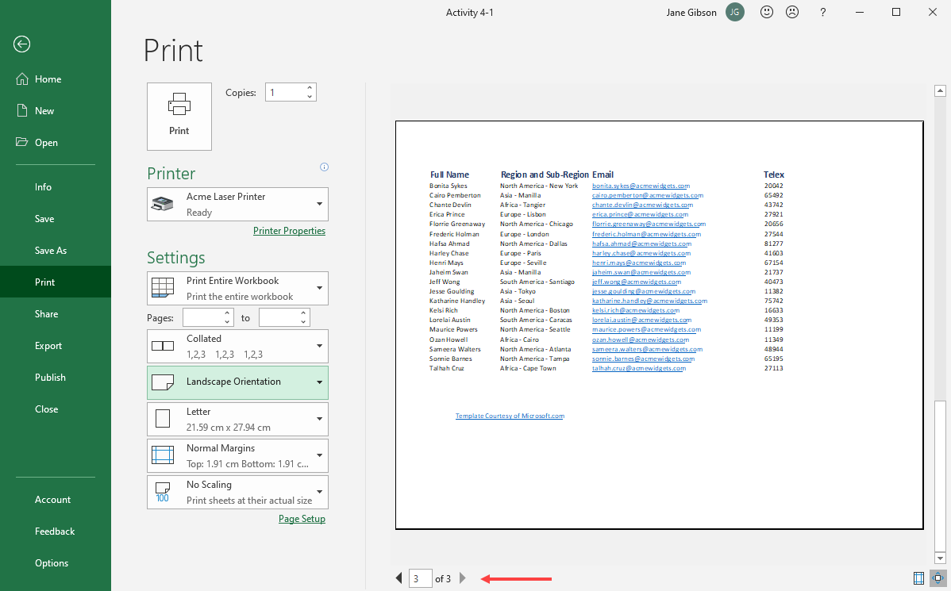

10. Apply the same settings to pages 1 and 2, by first clicking the **Previous page** button, and again clicking **Portrait Orientation → Landscape Orientation**:

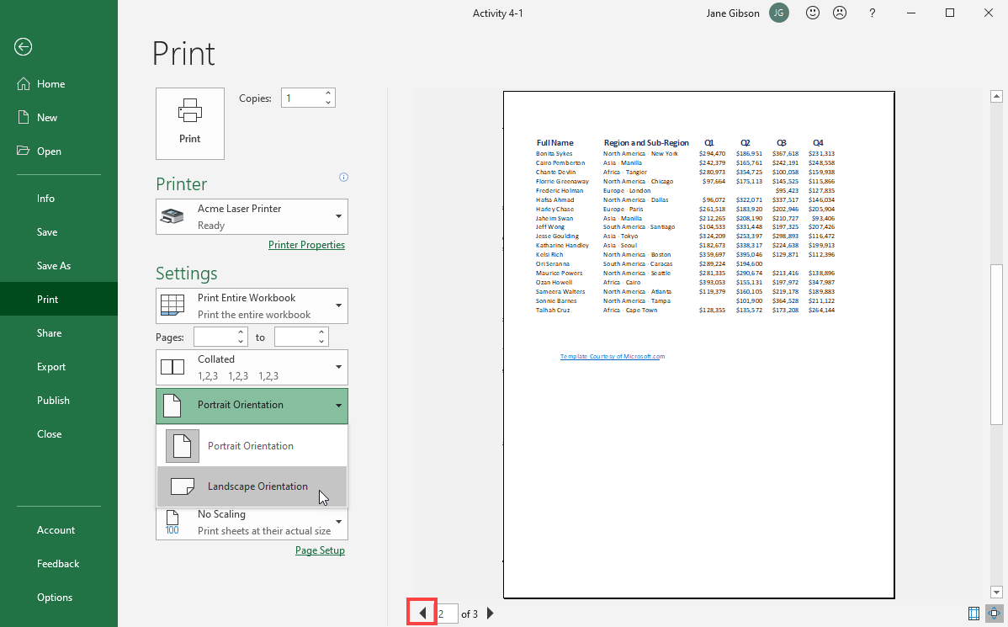

11. Save your workbook as Activity 4-1 Complete. Close Microsoft 365 Excel to complete this activity.

12. Now, you can check out an example of a completed document in the link below:

[Completed exercise: Previewing a Workbook Before Printing](https://www.coursera.org/learn/microsoft-excel-fundamentals/resources/DNQv8)

Exercise: Refining the page layout and applying print options

**Note**: You can pass this course and all graded assessments without access to the downloadable version of Excel.

**How to complete this exercise**

To complete this exercise, you will need access to Microsoft 365 Excel.

**Note:** Keep in mind that if you are using free Office for the web or another version of the Microsoft 365 Excel application some features covered in this exercise may not be available.​

**Free Office for the web**

If you do not have access to Microsoft 365 Excel, you can use Free Office for the web. This version of Office allows you to view and edit files in apps like Word, Excel, and PowerPoint. This free service is available to anyone with a Microsoft account.

**Access Microsoft Account**

[Log in to your Microsoft account.](https://account.microsoft.com/) Type the email, phone number, or Skype sign-in that you use for other services (Outlook, Office, etc.), then select Next. If you don't have a Microsoft account, you can select No account? Create one!

**Let's get started!**

You need to print a worksheet that shows sales information, but you would like to print it on four pages. Additionally, a page break must appear between the years and the regions. All pages also need title information for each row and column.

1. Click on the link below to open the Microsoft Excel exercise document you can use to complete this exercise.

[Exercise: Refining the Page Layout and Applying Print Options](https://www.coursera.org/learn/microsoft-excel-fundamentals/resources/jQxQ1)

2. Insert a manual page break by first selecting cell H1 and then clicking **Page Layout → Breaks → Insert Page Break**:

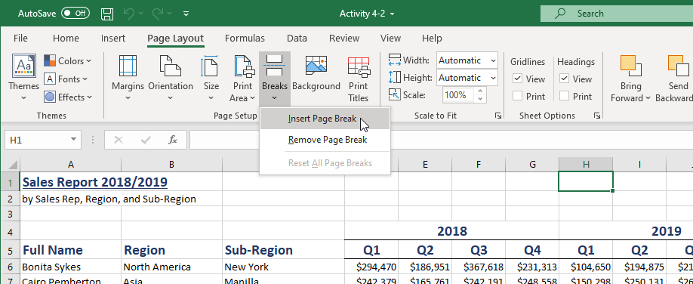

3. Insert another manual page break by selecting cell **H27** and then clicking **Page Layout → Breaks → Insert Page Break**:

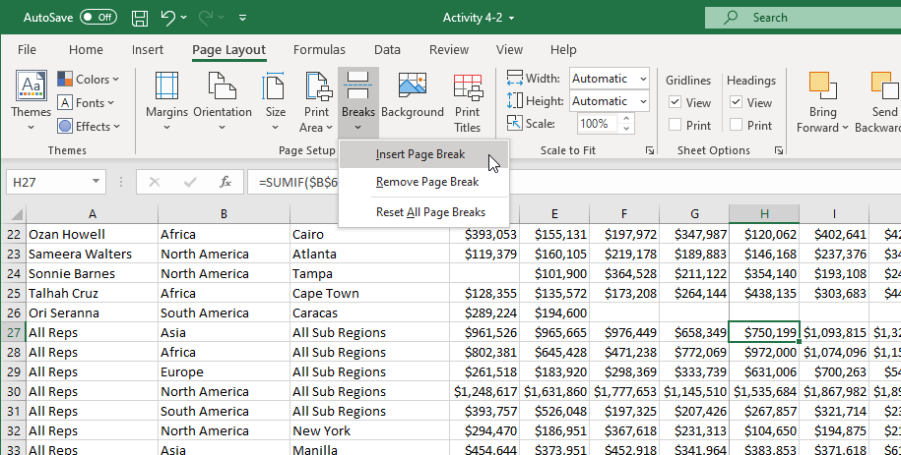

4. Next, use your cursor to select the **D6:K50** range:

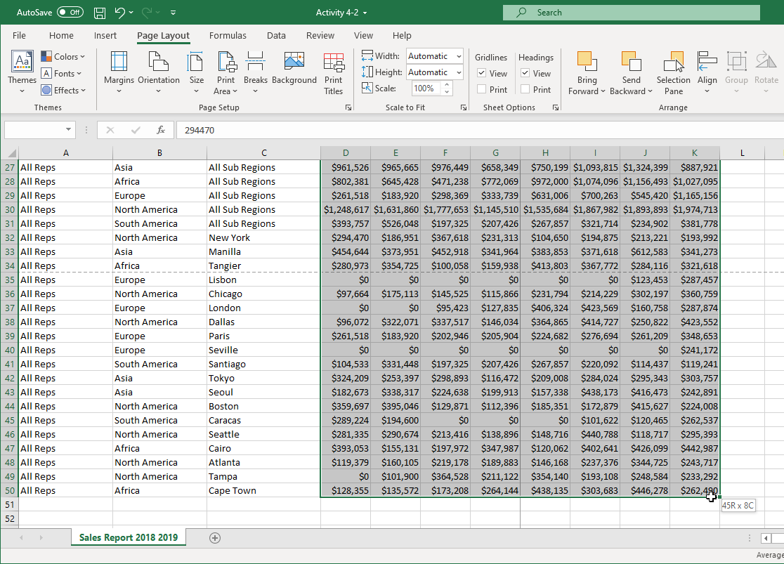

5. Click **Page Layout → Print Area → Set Print Area**:

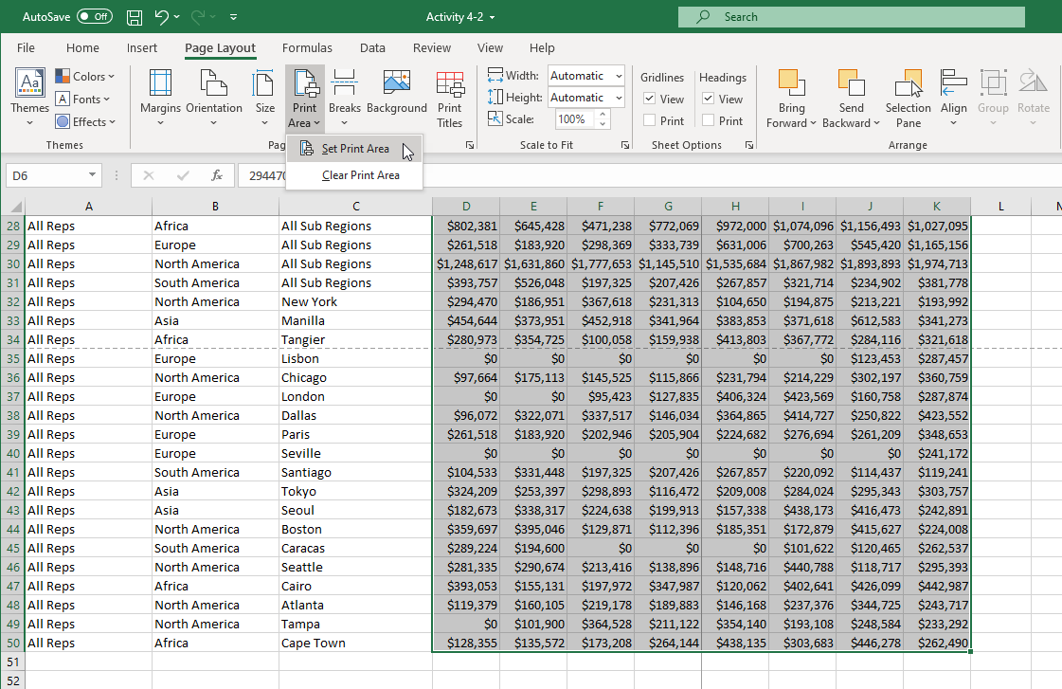

6. Next, with the previously selected cell range still selected, click **Page Layout → Print Titles**:

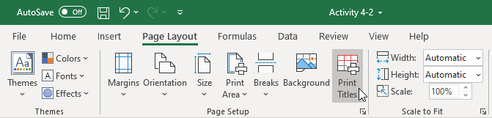

7. The Page Setup dialog box will now be open to the Sheet tab. Click the **cell selector button** on the far right of the **Rows to repeat at top** text box:

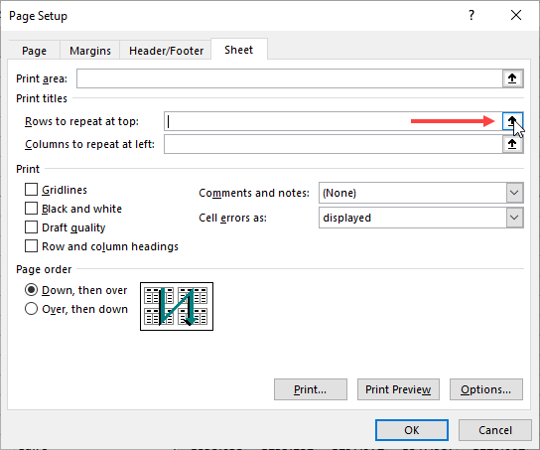

8. Your worksheet will now be shown. Click and drag to select **rows 1 through 5**:

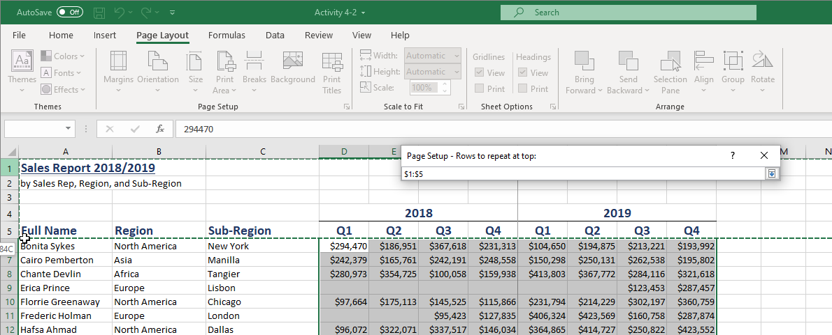

9. In the cell selector dialog box, click the cell selector button to return to the Page Setup dialog box, or press **Enter**:

Page Setup dialog box open, Cell selector button clicked 

10. Back at the Page Setup dialog box, click inside the **Columns to repeat at left** text box and type “**$A:$C**”:

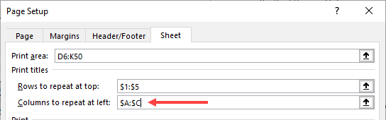

11. Click **OK** to apply the new settings:

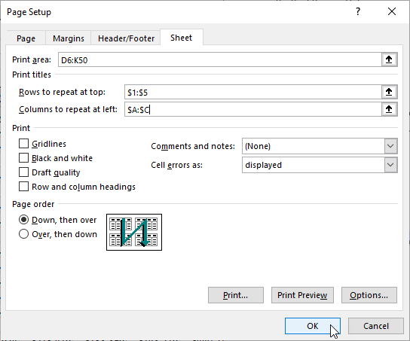

12. Click **File → Print**:

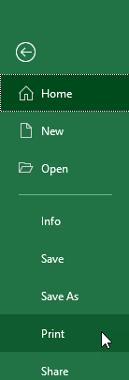

13. Examine the preview portion of this screen. You will see that the current worksheet has been divided into four pages. Each page has both column and row titles:

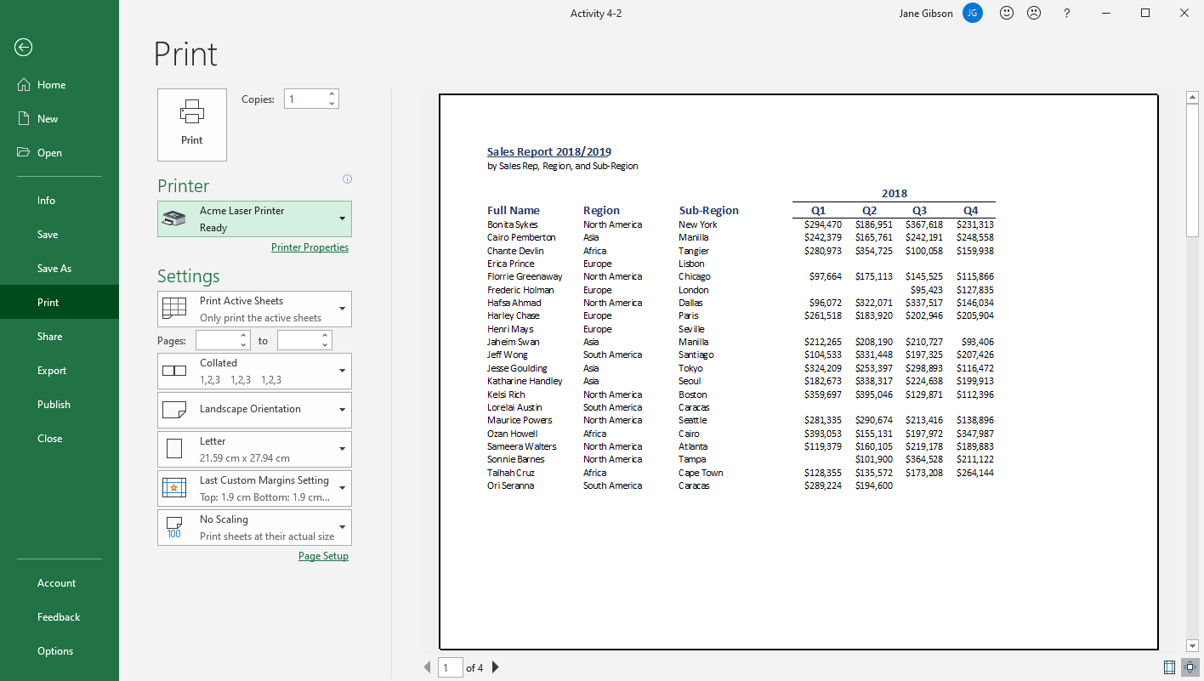

14. Save your workbook as Activity 4-2 Complete. Close Microsoft 365 Excel to complete this activity.

15. Now, you can check out an example of a completed document in the link below:

[Completed exercise: Refining the Page Layout and Applying Print Options](https://www.coursera.org/learn/microsoft-excel-fundamentals/resources/X5pHY)

Exercise: Formatting text

In this activity, you will format header rows and a title in your worksheet.

1. Click on the link below to open the Microsoft Excel exercise document you can use to complete this exercise.

Exercise: Formatting text

2. First, let’s format the header row of the Financial Data sheet. Select Row 1:

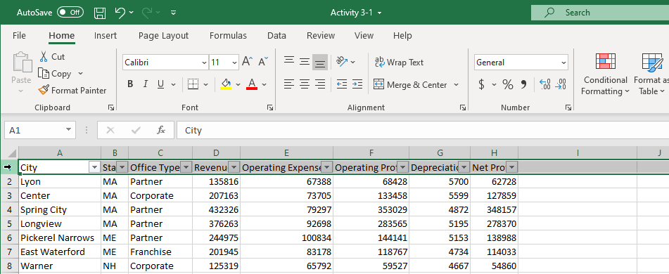

Excel workbook open, Row 1 was selected

3. Click the Increase Font Size button twice:

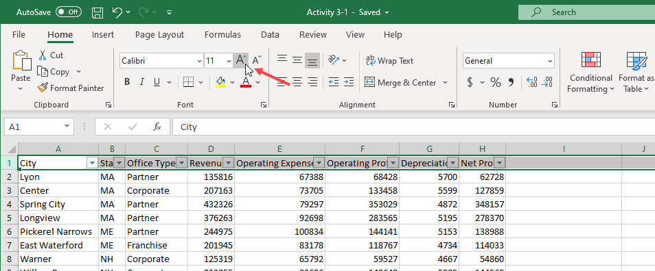

Excel workbook open, Increase Font Size option clicked twice

4. The value in the Size menu should now be 14:

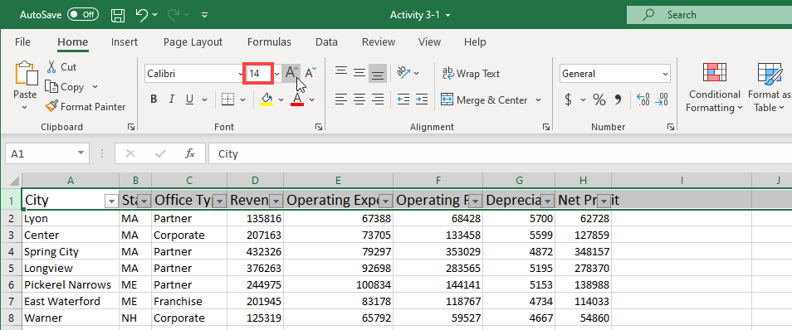

Excel workbook open, the size of the font changed to 14

5. Apply the Bold effect:

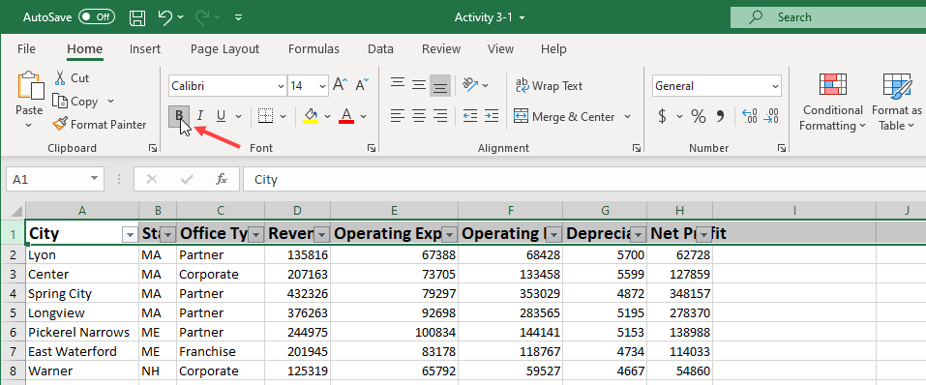

Excel workbook open, Bold option selected

6. Click the drop-down arrow next to the Font Color command:

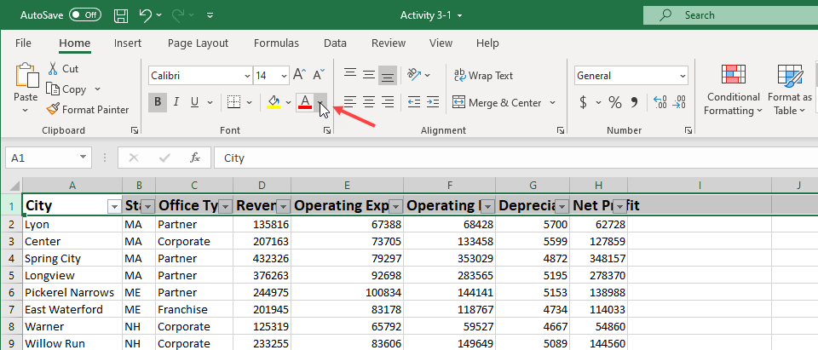

Excel workbook open, Font color drop-down arrow clicked

7. Click the Blue swatch in the Standard Colors palette:

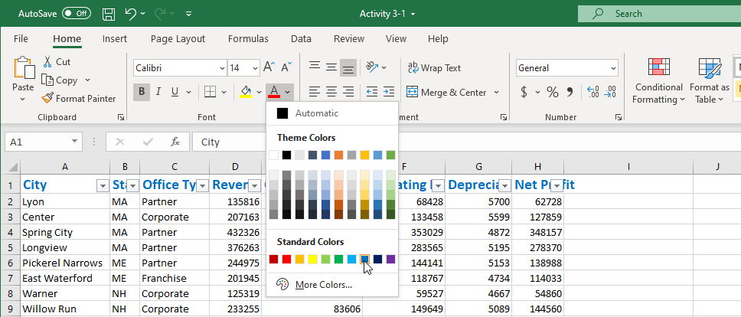

Excel workbook open, Standard Colors palette open, Blue Swatch color chosen

8. Because of the font changes, the data no longer fits in the cells. Press Ctrl + A to select the entire worksheet. Click Home → Format → AutoFit Column Width:

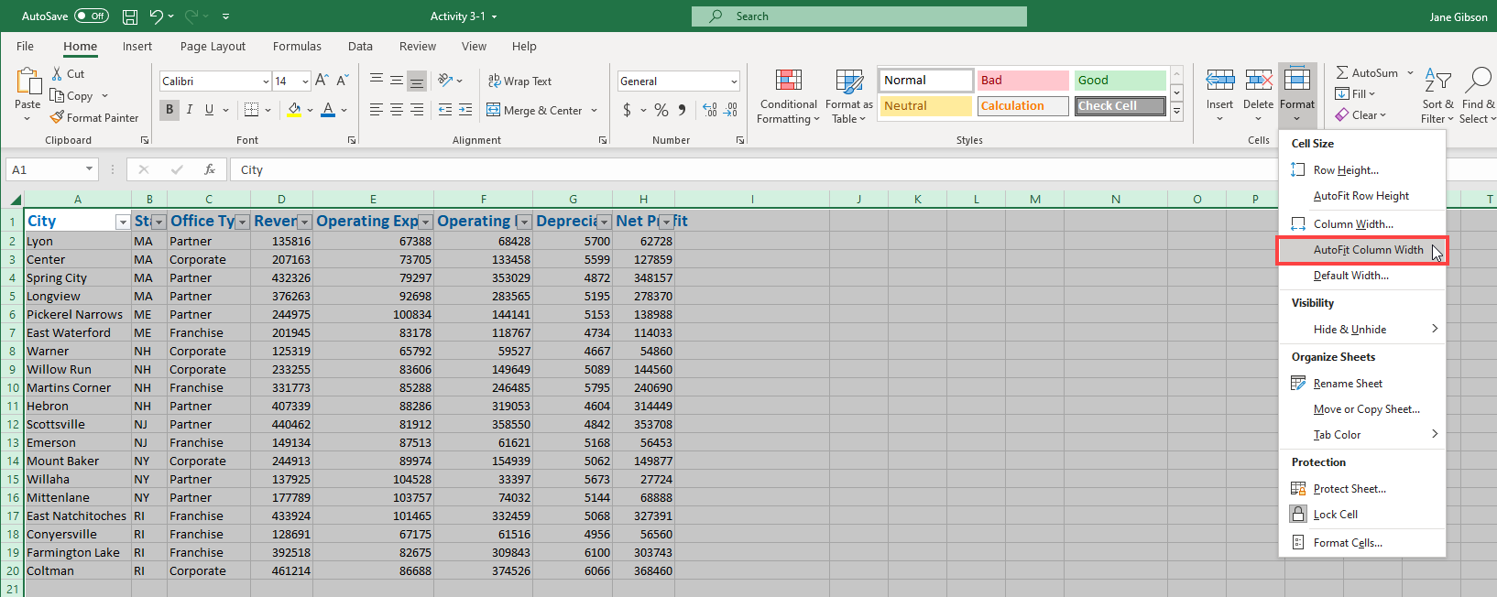

Excel workbook open, entire workbook was selected, Home tab selected, Format and AutoFit Column Width were clicked

9. Now, let’s copy the header row formatting to the second sheet. Click any cell in Row 1 to select it and click Home → Format Painter:

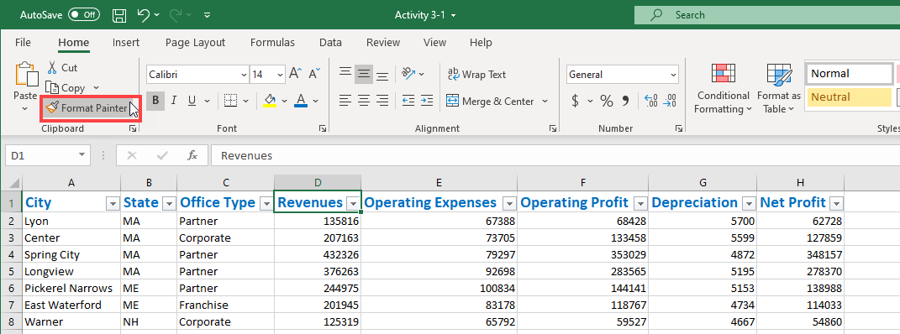

Excel workbook open, random cell in Row 1 selected, Home tab selected, Format Painter clicked

10. Click the Financial Scorecard worksheet tab:

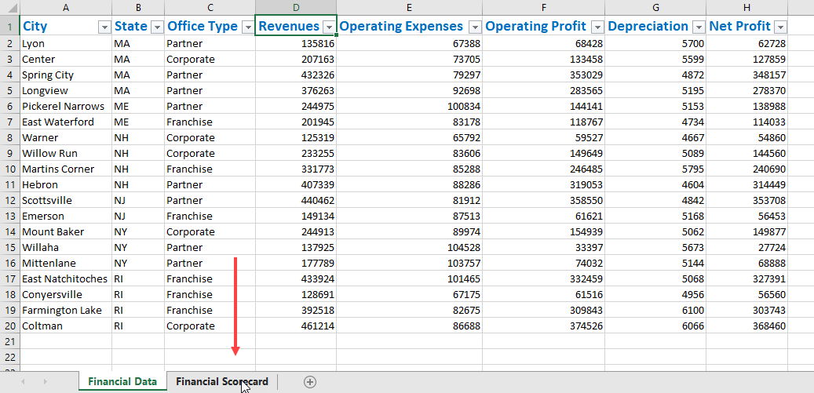

Excel workbook open, Financial Scorecard worksheet tab selected

11. Click cell A1:

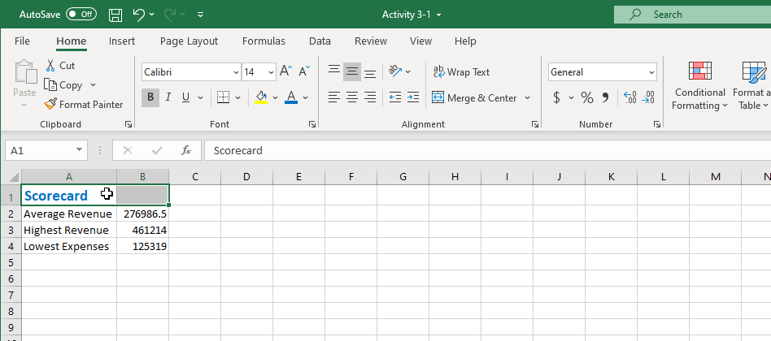

Excel workbook open, Cell A1 selected

The formatting will be applied; notice that the Merge & Center formatting option has been removed as part of this process. We will fix this in a later activity.

12. Save your workbook as Activity 3-1 Complete. Close Microsoft 365 Excel to complete this activity.

13. Now, you can check out an example of a completed document in the link below:

Completed exercise: Formatting text